**BON2 - 55 - 350**

**HIGH PRESSURE BOOSTER FOR NITROGEN**

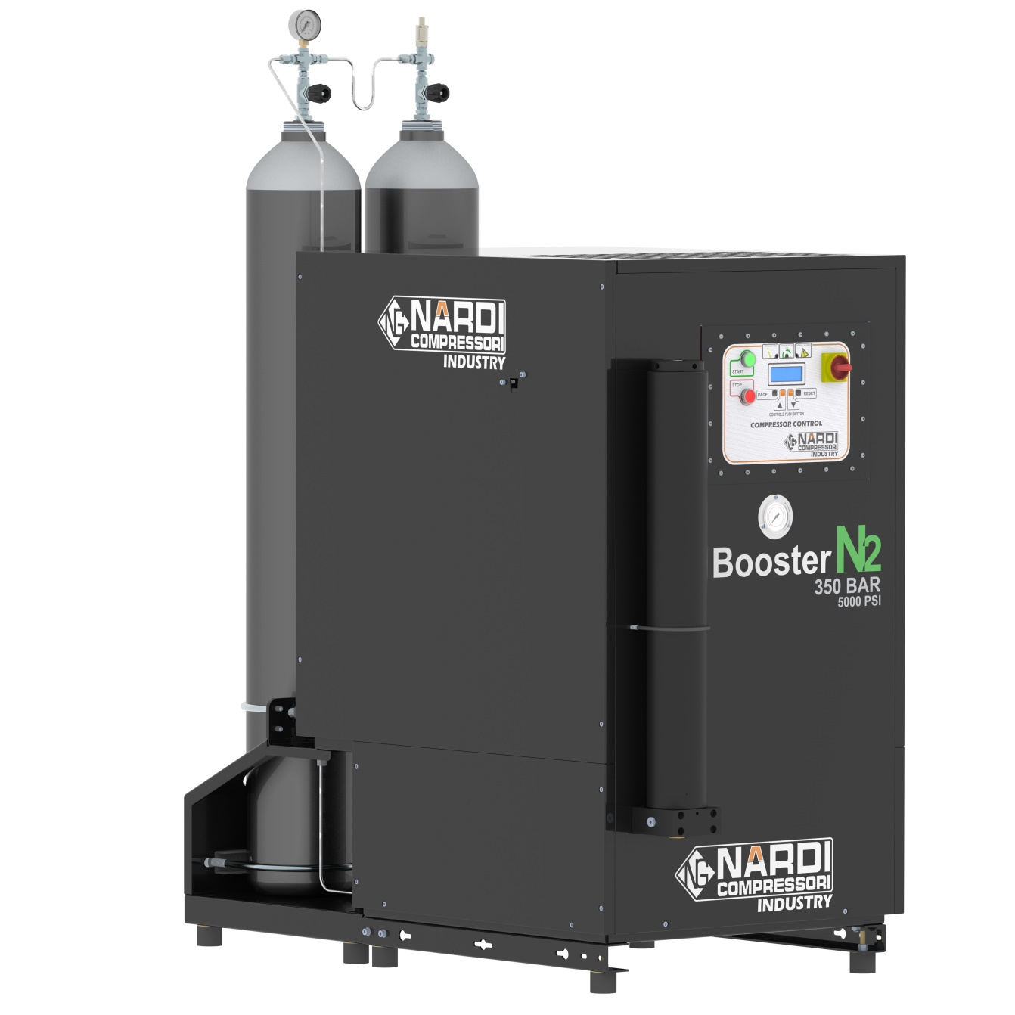

***User’s and Maintenance Manual***

This User’s and Maintenance Manual contains general information and instructions for the operation and maintenance of high pressure booster compressor. All users must read this manual carefully and understand it in its entirety before operating the machine.

**WARNING.** The operation of this machine is to take place only after having read this manual in all its parts.

*INDEX*

**1  BASIC INFORMATION page 05**

1.01 Warning Symbol Explained page 05

1.02 Precautions page 05

1.03 Introduction page 05

1.04 Description of the Compressor Block page 06

1.05 Description of BON2-55-350 page 06

1.06 Technical Datasheet BON2-55-350 page 08

**2 SAFETY REGULATIONS FOR THE USE OF THE COMPRESSOR page 09**

2.01 Identification of Safety Regulations for the Operators page 09

2.02 Safety Regulations for the Operators and for the Proper Use of the Compressor page 09

2.03 Safety Essentials page 09

2.04 General Safety Considerations page 10

**3 WARRANTY AND ASSISTANCE page 11**

3.01 Warranty of the Compressor page 11

3.02 Maintenance and Assistance page 11

**4 INSTALLATION page 12**

4.01 Compressor installation pag. 12

4.02 Unpacking and Handling pag. 13

4.03 Placement in Open Air pag. 13

4.04 Placement in a Closed Room and Minimum Requirements of the Room pag. 13

4.05 Room with Artificial Ventilation pag. 14

4.06 Suction Gas and check suction pressure gas pag. 15

4.07 Electric Line Connection pag. 15

4.08 Pressure and flow needed nitrogen to the compressor pag. 16

**5 QUICK STARTING GUIDE pag. 16**

**6 OPERATION AND USE pag. 17**

6.01 Preparing to Start the Compressor pag. 17

6.02 Electronic control Panel pag. 18

**7 MAINTENANCE AND SERVICE pag. 23**

7.01 Maintenance Operations pag. 23

7.02 Lubrication System pag. 23

7.03 Oil pag. 24

7.04 Oil Change pag. 24

7.05 Change Type of Oil pag. 24

7.06 Change oil filter and oil separator pag. 24

7.07 Alarm oil level pag. 25

7.08 Maintenance of Intermediate Separators pag. 25

7.09 Sucton and drain solenoid valve pag. 25

7.10 Pressure transmitter, pressure switch pag. 25

7.11 Carbon filter for nitrogen gas pag. 26

7.12 Carbon Filter Cartridge pag. 26

7.13 Pressure Maintaining Valve pag. 26

7.14 Heads and Compression Valves pag. 27

7.15 Valve Replacement – First Stages pag. 27

7.16 Valve Replacement – Second Stage pag. 28

7.17 Maintenance of oil separator pag. 28

7.18 Safety Valves pag. 28

7.19 Automatic Condensate Drain pag. 29

7.20 Special Waste Disposal pag. 29

7.21 Trouble-shooting pag. 30

**8 SPARE PARTS pag. 31**

**9 MAINTENANCE SCHEDULE TABLE pag. 46**

**1 *BASIC INFORMATION***

**1.01 WARNING SYMBOL EXPLAINED:**

This manual contains special messages to bring your attention to important information regarding safety and proper operation of the machine. The symbol below is placed in different parts of the manual next to paragraphs that all users must be fully familiar with. Make sure you read all the information carefully to avoid injury and/or machine damage.



**1.02 PRECAUTIONS:**

**The compressors are manufactured in accordance with the EC Machinery Directive 2006/42/EC, in accordance with the Law on General Product Safety dated 01/05/2004 on noise emissions and in accordance with the Machinery Directive, Annex I, Section 1.7.4. and following. The machine is constructed in a workmanlike manner and in accordance with technical and operational aspects of safety management.**

**NARDi COMPRESSORI also declares that the compressor has been subjected to a compliance pressure test, certifying with our 'DECLARATION OF CONFORMITY'' that the product complies with Pressure Equipment Directive 2006/42/EC.**

**Before using the compressor we recommend reading carefully the following indications:**

1. Read carefully the manual for the proper operation of the compressor.

2. Do not allow the gas that comes out from the compressor to be directed to people or animals.

3. Do not operate the compressor in damp places and/or places without good air ventilation.

4. Make sure the compressor is placed in a stable position.

5. The maximum pressure of the compressor is clearly indicated on the compressor itself.

6. When using the compressor place it in a fresh, well ventilated location and away from heat sources.

7. The compressor can reach high temperatures during operation.

8. Do not to allow children to handle the compressor even when it is turned off.

9. Do not use the compressor to suck/compress gases with an oxygen content higher than 21%.

**1.03 INTRODUCTION:**

***Booster BON2-55-350*** is a high pressure compressor used to compress nitrogen. The maximum compression pressure can arrive at 420 bar and the exercise pressure can be min 150 bar to max 350 bar.

Main parts of the compressor:

•  Pump Unit

* Electric Motor

•  Series of separators and filter

•  Filling hoses and connectors for cylinders

•  Protection and anti-vibration system

•  Automatic condensate drain*

•  Electronic control system*

* Automatic start and stop system*

**1.04 DESCRIPTION OF THE COMPRESSOR BLOCK:**

The combined pumping **BON2-55-350** has a range of use for high pressure nitrogen up to a maximum of 330 bar (4700 psi). The compressor consists of three stages put into operation by three pistons. The early stages are in the center and right, the second stage to the left of the figure (Figure 1).

The pumping unit forms a single body with the separators that are positioned between the cooling coils of the various stages. The flywheel does not need to be balanced because of the use of ultra-light alloys, while the compressor has a complete tree of counterweights that cancel the vibrations due to the dead time or not compression.

The movement of the pistons is transmitted by the connecting rods by means of roller bearings. Latter bear high loads and allow this mechanism to be very robust. The cylinders are made of aluminum with a rod iron drowned inside.

This special feature allows the machine to be technologically the most advanced product on the market. The benefit of this is that the temperature is disposed much faster from the cooling fins and, compared to cast iron, a higher resistance to corrosion.

The machine has a large oil sump well containing 3.5 Liters, a gear pump for the forced lubrication followed by a filter for the oil and a magnet that holds all the ferrous parts deposited in the cup. In this manner, the oil will be always clean making, consequently, the machine more reliable.

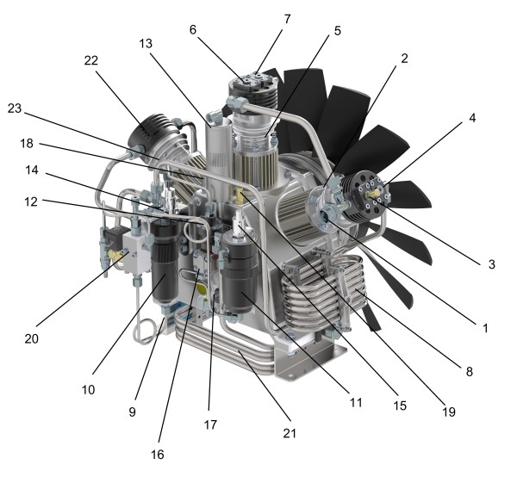**COMPRESSOR BLOCK COMPONENTS:**

1. Suction

2. Cylinder 1 - First stage of compression

3. Valve in 1 stage

4. Valve out 1 stage

5. Cylinder 2 - First stage of compression

6. Valve in 1 stage

7. Valve out 1 stage

8. Cooling 1 cilinder

9. Cooling 2 cilinder

10. Condensate separator 1 stage

11. Condensate separator 2 stage (HP)

12. Lubrification oil filter

13. Vapor oil separator filter

14. Safety valve 1 stage

15. Safety valve 2 stage

16. Oil pump

17. Automatic lever oil

18. Tap oil

19. Monoblock safety valve

20. Automatic condensate drain valve complete

21. Cooling 2 stage

22. Head 2 stage

23. Cylinder 2 stage

**1.05 DESCRIPTION BON2-55-350 :**

The compressor **BON2-55-350** is composed of a very robust structure, designed to clear the vibrations discharged to the ground, and at the same time, capable of absorbing more than 60% of the noise.

This is possible thanks to an internal insulation in sound-absorbing material, which guarantees a lower noise level of 70db (A).

All the details, the internal structure and the walls that line the latter, are painted with epoxy powder and then put in the oven, giving outstanding resistance to corrosion. This ensures a greater durability of the materials, and consequently, a longer duration of the pumping unit also inside.

The filtering unit of nitrogen, is positioned on the front of the compressor,, so as to simplify the operation of replacement of the filter cartridge. It is also possible to add as optional accessory, another filtering unit to be attached to that already supplied.

Always on the front, we find the control panel with pressure gauge and the electrical controls and four outputs previously prepared with a thread ¼ gas. While the automatic condensate discharge is positioned in the rear of the compressor.

**DESCRIPTION OF BON2-55-350:**

1. Pumping unit

2. Electric motor

3. Filter System PAC 3

4. Electronic panel

Rear output for storage (optional)

5. Pressure gauge compressor

Input ventilation air compressor

6. Input / Suction nitrogen - G1 "(DN25 pipe) (pressure Min. 4 Bar - Max. 11 Bar)

7. Sound absorbing

8. Storage canopy

9. Storage tank (2 x 50LT 300Bar)

10. Pressure gauge storage

11. Safety valve storage

12. Manifold

OPTION: can add one rear storage up 100 to 800 liters capacity, directly connected to the compressor, which is mounted on a frame together with the compressor. The machine is completely assembled, and storage is comprised of pressure gauge, valve, safety valve and outlet fitting male G1 / 4 '. The storage has a nominal pressure of 300 Bar. Every 10 years, the cylinders must be inspected and tested.

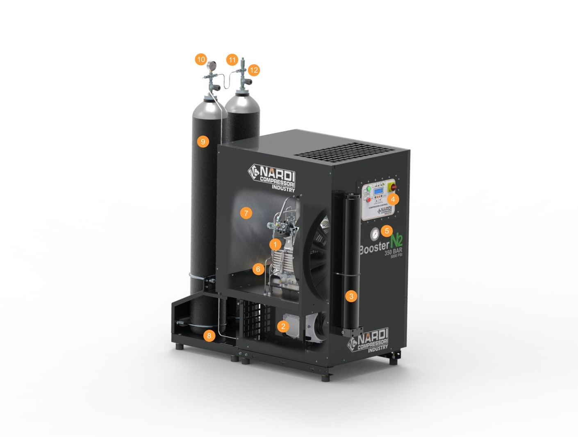

**1.06 TECHNICAL DATASHEET:**

|  |  |  |  |  |
| --- | --- | --- | --- | --- |
| ***TABELLA CARATTERISTICHE TECNICHE - TECHNICAL DATA*** | | | | |
| ***Description*** | ***Descrizione*** | ***Unità - Unit*** | ***BON2-55-350*** | |
| Max Working Pressure | Pressione di esercizio | PN |  | 350 bar |
| Charging rate | Aria Resa | L/min. – m3/h – cfm | Read down tab. | |
| Safety Valve Pressure | Pressione di esercizio | Bar |  | 350 bar |
| Compressor block | Gruppo pompante | Name – Nome | BON2-55-350 | |
| Number of stages | Numero di stadi | N° | 2 | |
| Number of connecting rods | Numero di bielle | N° | 3 | |
| Pressure 1st Stage | Pressione 1° stadio | Bar | 90 bar | |
| Pressure 3th Stage | Pressione 3° stadio | Bar |  | 350 bar |
| Compressor Block Oil capacity | Capacità coppa dell’olio | Liter – gal(US) | 3,5 – 0,924 | |
| Speed Compressor | Giri Compressore | r.p.m. | 1350 | |
| Oil Type | Tipo di Olio | Name – Nome | NARDI SYNTHETIC 150 | |
| Environment working temperature | Temperatura ambiente di lavoro | °C / °F | From -25°C to +45°C / From -13°F to +113°F | |
| Max inclination of compressor | Max inclinazione del compressore | Grade – Gradi | 5° | |
| Max operating height | Max altezza dal livello del mare | Meter / Feet | 2000 / 6500 | |
| Power pump weight | Peso gruppo pompante | Kg. / lb | 47 / 105 | |
| Dry and oil intermediate separator | Separatori acqua olio | N° | 2 | |
| Filtration | Sistema Filtrante | Name – Nome | PAC 3 - N2 | |
| Interstage coolers and after coolers | Tubi di raffreddamento | Material – Materiale | Acciaio Inox – Stainless Steel | |
| Electric Motor | Motore elettrico | Phase – Fasi | Three | |
| Operating Voltage | Tipo di Voltaggio | Volt / Hz | 400V – 50hz | |
| Power | Potenza Motore | Kw | 5.5 | |
| Noise level | Pressione Sonora | dB | 76 | |
| Type of enclosure | Protezione | IP | 55 | |
| Current Rating | Assorbimento | Ampere | 12 | |
| Weight | Peso | Kg. / lb (US) | 260 / 573 | |

**2 *SAFETY REGULATIONS FOR THE USE OF THE COMPRESSOR***

**2.01 IDENTIFICATION OF SAFETY REGULATIONS FOR THE OPERATOR:**



It 'very important to check and know the danger points of the machine before using it. To help in this, were placed the stickers that help you with stylized images to identify: High Voltage, valves in pressure, Fans rotation, etc .. Hot Spots

In addition to this, the machine are mounted some components for accident prevention and global security in the event of a malfunction or failure, intervene so as not to cause danger to the life of the operators.

These items must always be present and can not be changed.

In case of intervention contact our technicians.

The operator must ensure the good condition of the equipment and the perfect functioning of the safety items.

  The compressor must be monitored periodically by the operator and technicians who will replace worn or damaged.

**2.02 SAFETY REGULATIONS FOR THE OPERATOR AND FOR THE PROPER USE OF THE COMPRESSOR:**



The clerk at the compressor must have adequate technical knowledge on current regulations and must know perfectly functioning machine. In case of delegation of work must provide to inform the second person of all operations to be performed.

The compressor is designed to compress pure nitrogen already esiccato.

The nitrogen must be available at the input with an adequate flow rate and a pressure which must not be less than 3 Bar and should not be higher than 11 Bar and passing through the solenoid valve of the suction cycle starts compression / filtering up to the maximum pressure output of the compressor.

**2.03 SAFETY ESSENTIALS:**

**• Recharge only inspected cylinders never exceed the working pressure.**

**• The compressor must aspire pure nitrogen, you should not be placed in areas where there are dust, danger of explosion, corrosion, fire.**

**• If the compressor is driven by a gasoline or diesel use is prohibited indoors. The refueling must be done with the machine off.**

**• Make sure that when you do maintenance or you want to replace some part of the compressor, it is not under pressure and the power plug is disconnected from the power line.**

**• Replace filters regularly purifying nitrogen only products Original NARDI COMPRESSORI (material tested).**

**• Drain the condensate regularly if the compressor has a manual drain. In the case of automatic discharge check that this happens in periods of not more than 15 minutes, check the daily operation discharges manuals.**

**• When not using the compressor off the power, never give jerks to the wire but use the plug to unplug it. Make sure that the cable does not run against sharp edges or bend angle (in this case use extension).**

**• Periodically check the condition of the hoses (high pressure hoses) especially in the vicinity of the connections and in the case of the present small defects must be replaced. Must be replaced every 12 months.**

**• Periodically check the tightness of connections.**

**• Do not repair damaged parts if you do not have original parts NARDI COMPRESSORI.**

**• Do not modify the machine unless expressly authorized in writing by NARDI COMPRESSORI.**

**• In case of visible wear and tear of any component of the compressor, do not use it until they are replaced with one original and check that it has damaged other parts of the machine.**

**• When the machine is turned on, make sure that there are people in contact with it.**

**• Be careful of all the moving and not going to contact them.**

**• Do not change the cooling system of the compressor and make sure it is positioned so as to ensure proper air circulation.**

**• In the ignition phase check that the direction of rotation of the compressor is equal to that indicated by the arrow on the crankcase.**

**2.04 GENERAL SAFETY CONSIDERATIONS:**

1. The operator qualified to use the compressor, shall be aware of all the provisions and devices to control the machine, tools, indicators and all the information on the various stickers/labels attached to the machine.
2. Always have first aid supplies, and a CO2 fire extinguisher. Make sure the extinguisher is fully charged and ready to work at all times.

1. When operating the compressor, use appropriate protective clothing such as safety shoes, goggles, gloves and so on.
2. Always disconnect the power cable when performing operations within the compressor, never perform any operations on it with the power on while the compressor is in operation.

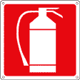 

**3 *WARRANTY AND ASSISTANCE***

**3.01 WARRANTY OF THE COMPRESSOR:**

The compressor BON2-55-350 of our production is guaranteed by NARDI COMPRESSORS for a period of twelve months from the date of purchase and stated on the label on the compressor.

In the time of production and testing will be placed a label that will make the machine complies with CE regulations and that will bring this symbol, in the event that it is disconnected or altered WARRANTIES will decay.

For that guarantee to be valid, the purchaser has complied with the provisions of the contract and that the compressor has been used as indicated by us and has not been altered or modified granted and confirmed by NARDI COMPRESSORS.

Do not answer the warranty:

• If the machine has not been used properly (as described in this instruction manual)

• Not guaranteed to consumables and regular maintenance, especially if used improperly.

• If you were not used original parts NARDI COMPRESSORI.

• If you are sucked / compressed gas different from nitrogen.

The replacement of the defective part will be performed free of charge at the plant in Montecchio Maggiore of NARDI COMPRESSORI or in the seat of our authorized dealers.

Repairs and replacements made by NARDI compressors or from an authorized dealer, during the warranty period, will not extend its duration.

In the event that the repair done outside of NARDI COMPRESSORI, will be charged the shipping of spare parts (replacement of defective components should be performed only by trained technically that NARDI COMPRESSORI or our trained staff will assess' operator before it is made the replacement).

If replacing the piece needs a technical NARDI COMPRESSORI, travel expenses and travel expenses will be paid by the purchaser.

**3.02 MAINTENANCE AND ASSISTANCE:**

To order spare parts please contact or visit our dealers in your area. In case of difficulty in finding a spare part, contact directly NARDI COMPRESSORI. We are available for any queries or further information and we will put you in contact with skillful technical staff to help you. If you need service or assistance, please contact us directly at:

**NARDI COMPRESSORI srl**

VIA MARCO POLO, 2

Tel 0444 159111

Fax 0444 159122

www.nardicompressori.com

**4 INSTALLATION**

**4.01 COMPRESSOR INSTALLATION:**

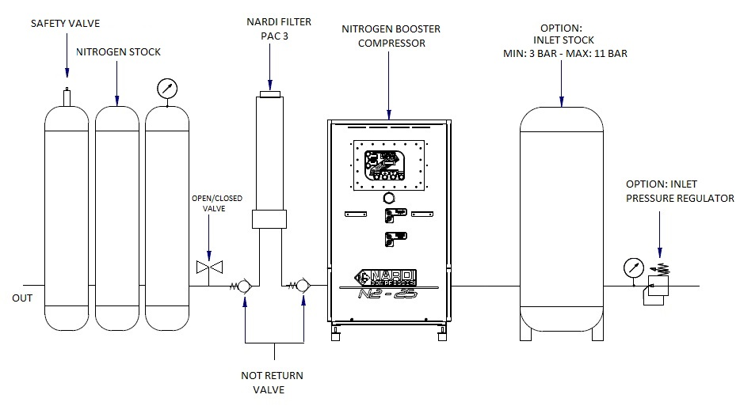

**4.02 UNPACKING AND HANDLING:**

The compressor is shipped on a pallet, is covered by a box and at the end secured with a strap. After unpacking it is important to check if the transport damage and, in the presence of these, it is important to inform the carrier and the dealer as soon as possible but no later than 7 days from delivery.

The compressor BON2-55-350 is designed to facilitate the handling. In fact, if you look at the bottom, has an opening which serves to be able to enter with a trans-pallet or with a forklift.

The compressor is mounted on anti-vibration who avoid transmitting vibrations to other things nearby. However, must be positioned in a stable point.

The pumping unit is not corrosion resistant marine permanent. In case come into contact with corrosive agents is recommended to clean the surface and protect it with protective sprays corrosion. Always be careful to the electrical part.

**4.03 PLACEMENT IN OPEN AIR:**

 It 's very important to place the compressor in open places. The compressor must not be placed in closed watertight.

You have to place the compressor in a cool, sheltered.

Watching chapter 4:04 to the proximity of the walls and roof

**4.04 PLACEMENT IN A CLOSED ROOM AND MINIMUM REQUIREMENTS OF THE ROOM:**



The compressor positioned in a room, requires a continuous recirculation of air for cooling.

Within it there must be no liquid that can evaporate (solvents, additives, ... .etc.).

E 'preferable to place it in the vicinity of open windows during its operation so as to ensure the recirculation of air for cooling the compressor.

The minimum characteristics of the room are the following:

• The temperature of the room that must not be less than 5 ° C and should not be above 45 ° C with proper ventilation (see tab. A).

• The room must be dry and clean, there must be no dust deposits that may be drawn from the compressor.

• If the same room is posizionassero two or more machines to make sure that the size is adequate (see Tab. C).

• Position the compressor preferably in the coolest area of the room. In the case of natural ventilation sure that the compressor is as close as possible to the fresh air intake and it has the appropriate size. Besides this there must be a 'opening in the upper part of the room that gives the possibility to dispose of the hot air, and also has the appropriate size (see tab. A and Fig. 2). The two openings must not be on the same wall, otherwise you must make sure to direct hot air upward.

**Table A : Minimum room size with natural ventilation.**

|  |  |  |  |  |  |
| --- | --- | --- | --- | --- | --- |
| ***Volume and Height of the Room*** | | | | | |
| Volume >50 m³ - Height >2,3 m | | Volume >100 m³ - Height >3 m | | Volume >200 m³ - Height >4 m | |
| Intake (A) | Outlet (B) | Intake (A) | Outlet (B) | Intake (A) | Outlet (B) |
| 0,95 m² | 0,78 m² | 0,63 m² | 0,52 m² | 0,25 m² | 0,21 m² |

Tab. A

Tab. B

|  |  |
| --- | --- |
| ***Minimum Distance from the Walls*** | |
| C | 0,10 m |
| D | 0,50 m |
| E | 1,00 m |

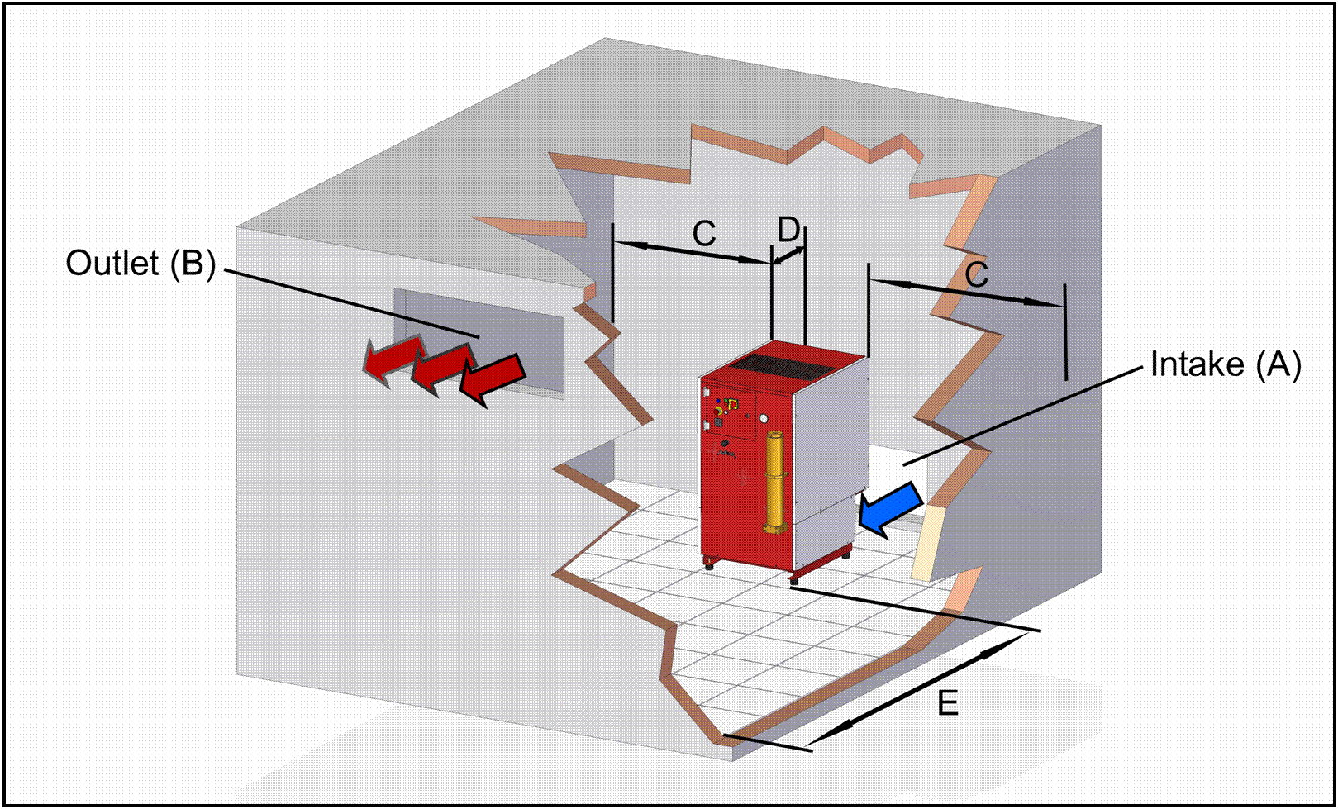  
 Fig. 2

CAUTION: The size of the openings depend on the heat sources and machinery placed in the room. The dimensions indicated in Table A are for a compressor PACIFIC 35 M and vary depending on the volume and height of the room. The height of the room should not be lower than 2.3 meters and the minimum distance from the top panel of the compressor to the roof must be 1 meter.

If in the same room two or more machines are placed you have to calculate the ventilation adequate for both machines to work properly. Use the formula on Table C for your calculation.

|  |
| --- |
| Volume of Air Intake ( m² ) = Number of Compressors x Volume of Air Required for the Room ( m² ) x 1,6 |

Tab. C

pericolo

If the room volume is lower than indicated, and vents for air circulation less than those indicated, it is mandatory to insert artificial ventilation (see section 4.04)

**4.05 ROOM WITH ARTIFICIAL VENTILATION:**

In the case of artificial ventilation it is important to check that the fresh air inlet is positioned at the bottom and the outlet is positioned at the top in two different walls. In the case of extractor fan make sure that the flow rate is equal to or greater than that indicated by calculation (see Table D).

|  |
| --- |
| Minimum air circulation ( m³/h ) = Capacity of the compressor ( l/min ) x 7,5 |

Tab. D

To ensure that there is sufficient ventilation and that the fan flow rate is adequate simply measure the speed of the outgoing air (m / sec) and the section of the exhaust duct where the measurement is made (m²) and then calculate it using the formula in Table E.

|  |
| --- |
| Air circulation ( m³/h ) = Cross Sectional Area of the Duct ( m² ) x Air Speed ( m/sec ) x 3600 |

Tab. E

To calculate the dimensions of the intake duct, it is recommended that the speed of the incoming air is not less than 5 m / sec and should not be more than 10 m / sec. We suggest using the formula in Table F to calculate the cross sectional area of the duct with an air speed of 5 m / sec.

|  |
| --- |
| Cross Sectional Area of the Duct ( m² ) = Minimum air circulation ( m³/h ) / 5 (Air Speed m/sec) x 3600 |

Tab. F

**4.06 SUCTION GAS AND CHECK SUCTION PRESSURE GAS :**

The tube of input / Suction is attached to the compressor via the sleeve 1 "G positioned at the rear of the compressor, is identified with the adhesive" SUCTION GAS ".

The tube must have a minimum section DN25 and the inlet pressure to the compressor must be between 3 Bar and 11 Bar.

If the inlet pressure is too low or too little flow (suction pipe too small), the moment of ignition will generate an alarm and the compressor.

In the event that the alarm is present all the time might be the cause:

- Line pressure too low.

- Pipe section too small.

The compressor is provided with a pressure switch for enabling suction. This pressure is calibrated by NARDI COMPRESSORS between 3.5 and 7.5 Bar. In automatic mode, the compressor comes on standby if the pressure drops below 3.5 bar, and restarts as soon as the pressure exceeds 7, 5 Bar. in this way the compressor can work continuously. The alarm control pressure is controlled by a pressure transducer which communicates the pressure to the control panel. If the pressure drops below or rises above 2 Bar 11 Bar, the compressor generates an alarm visible on the display, which must be manually reset by the operator.

 Free suction gas storage:

The suction pressure must necessarily controlled, and should be followed the parameters described in the specifications table, always making sure that the vacuum flow is adequate to the demand of the compressor.

The machine is however equipped with pressure transducers, which communicate in a timely manner with the electrical panel, and generate an alarm in case of lack of gas or too high pressure of the intake gas. The compressor is equipped with oil level alarm, which immediately stops the machine, and alerts the operator of the problem, which will look for the problem and add oil missing.

**4.07 ELECTRIC LINE CONNECTION:**

For electrical installation must follow these steps:

• On this manual is schematized the electric control of the compressor that indicates how to connect the compressor to the mains.

• Do check from an electrician that the system is in accordance with and bear the maximum absorption of the compressor indicated on the label of the EC NARDI COMPRESSORS.

• It is recommended to install a circuit breaker or fuse appropriate to the power consumption of the motor.

• Check that power is coming to the voltage required by the compressor and the power cord that is used is not undersized.

**• CAUTION:** When connecting the plug to make sure that the fan of the compressor turns in the right direction indicated by the arrow on the internal sleeve. To reverse the rotation just reverse two of the three phases of the power outlet. Your compressor may have the phase sequence, in this case will not turn on until it will invert the wires of the phase as indicated above.

• Make sure the grounding is connected firmly on the plug and electrical work.

• If you change the power cord make sure it is of adequate size.

**4.08 PRESSURE AND FLOW NEEDED NITROGEN TO THE COMPRESSOR :**

The compressor changes the flow rate of nitrogen based on the pressure with which we feed. Below we find the table with the supply pressures and flow rates depending on the pressure. This table is useful if you want to match to a nitrogen generator in line with the compressor Booster Nardi.

|  |  |  |  |  |  |  |  |  |  |
| --- | --- | --- | --- | --- | --- | --- | --- | --- | --- |
| **INLET PRESSURE** | *bar* | **4** | **5** | **6** | **7** | **8** | **9** | **10** | **11** |
| **FAD** | *L/min* | 140 | 190 | 250 | 310 | 360 | 420 | 480 | 550 |
|  | *m³/h* | 8,4 | 11,4 | 15 | 18,6 | 21,6 | 25,2 | 28,8 | 33 |
|  | *cfm* | 4,9 | 6,7 | 8,8 | 10,9 | 12,7 | 14,8 | 16,9 | 19,4 |
| **RPM** | *1/min* | 1350 | 1350 | 1350 | 1350 | 1350 | 1350 | 1350 | 1350 |
| **ELECTRIC MOTOR** | *kW* | 7,5 | 7,5 | 7,5 | 7,5 | 7,5 | 7,5 | 7,5 | 7,5 |
| **POWER CONSUMTION** | *kW* | 3,2 | 3,3 | 3,5 | 3,6 | 3,7 | 3,9 | 4,1 | 4,3 |

**5 QUICK STARTING GUIDE**



**WARNING: This QUICK does not replace the user manual and maintenance, but is intended to help the operator when the compressor starts, with fast and practical advice, which should be followed with extreme caution, and only after taking vision of all points of this booklet.**

*It is also recalled, for periodic maintenance of the compressor, to avoid disappointment.*

*Getting Started:*

SEQUENCE

OR

PHASE FAILURE

*- Position the compressor in the desired*

*- Connect the condensate drain pipe back to the reservoir oil recovery / condensation*

*- Connect the hose back suction*

*- Connect the outlet pipe nitrogen*

*- Check that the filter there is a cartridge*

*inserted*

*- Connect the compressor to the grid and provide power*

* *- Pay attention to the phase sequence, if it were connected incorrectly the electric panel will indicate SERQUENZA PHASE FAILED, in this case, reverse the two wires on the electrical plug*

- You can see the correct direction of rotation, making sure that air flowing out from the upper part of the compressor, and not from the lower

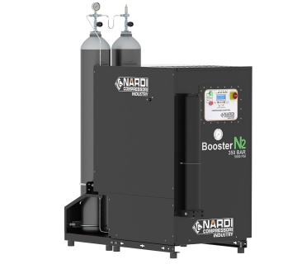

**6 OPERATION AND USE**

**6.01 PREPARING TO START THE COMPRESSOR:**

 This machine is designed to compress NITROGEN GASEOUS STATE.

It is forbidden to change the suction doing compress different from nitrogen gas or mixture of gases and nitrogen.

An intake / compression of a gas from nitrogen can lead to breakage or to 'EXPLOSION compressor.

All compressors are tested by NARDI COMPRESSORS before being sold, but for the power you need to follow these steps:

• Before turning on the machine, all the people who will use the compressor must read carefully the instruction booklet.

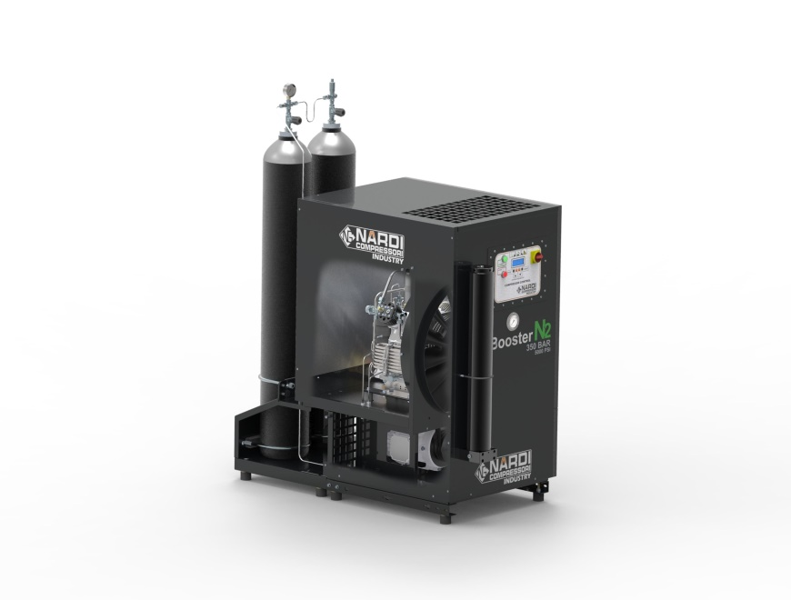• If the compressor has been standing for a period exceeding twelve months, it is advisable to change the oil and the presence of a technician perform a check-up.

• Check that the hose fittings and hoses are tight well.

  • Check that the air passage (rear) for cooling the compressor is not covered or obstructed.

• Check that the output of the upper air is not covered or obstructed.

• Check that the electrical panel is lit with white light LINE on.

• Every time you turn on the compressor do these checks and if something is not working properly, do not turn on the compressor and perform maintenance or contact a technician to fix the problem.

This model is equipped with an electronic panel that controls the compressor in all its functions.

Before switching to follow the above steps and then press the START button to start the compressor.

The compressor in automatic mode, will shut down only once at maximum pressure and will start just below the minimum pressure set.

The compressor in manual mode, will shut off when it reaches maximum pressure set, but must be reset manually for the next departure.

In an emergency, press the red STOP button, and the compressor will stop immediately.

In case of active alarm, correct the problem and press the RESET button.

**6.02 ELECTRONIC CONTROL PANEL:**

The electronic control system NARDI COMPRESSORS monitors the proper operation of the compressor: manages the pressures and temperatures of one or more compression stages; It manages the inlet pressure of the air or nitrogen; It manages how to use manual or automatic; displayed it keeps the working hours of the compressor and signals the need to perform the service after the hours of work scheduled; management of the electric motor; setting the maximum and minimum pressure during use; Menus available in four languages; Display contrast adjustable; It manages alarms and failures indicating precisely the problem; hardware outputs for interfacing with other operating systems.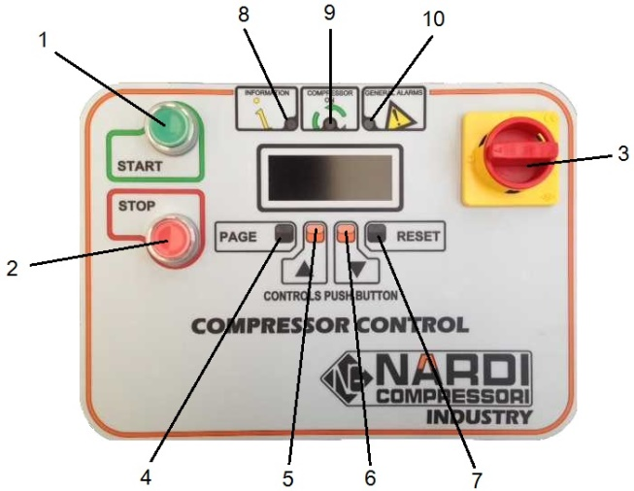

1. Start button compressor

2. Stop button or Emergency.

3. Door lock main switch.

4. Button form feed (PAGE)

5. Button salts (▲).

6. button down (▼).

7. reset button (RESET)

8. yellow LED information (ALARM NOT BLOCKING)

9. Green led compressor running.

10. Red LED for general alarm (ALARM BLOCKING)

**ELECTRONIC BOARD AND DISPLAY:**



WARNING: The control panel is an advanced component that allows you to monitor the compressor and at the same time change the parameters of use of the same.

The control panel is set by Nardi Compressors at time of production with standard or custom parameters.

The control panel is composed of the following buttons:

LINE SWITCH: This switch is used to give power to the electrical panel and all electrical parts. When the "0" no component is powered and it is important pull the plug in the case of transactions. The switch in position "I" blocks the opening of the control cabinet and the compressor and all its electrical components are supplied.

STOP BUTTON: This switch is reset and turns off the compressor, so once you have pressed to rotate the push-button to get it out and resume the normal position.

START BUTTON: Used to turn on the compressor.

BUTTONS PAGE - ▲ - ▼ - RESET: Used to scroll through the menu of the control panel and to modify parameters

LIGHT INFORMATION: This yellow LED indicates that the compressor has a fault.

COMPRESSOR LIGHT ON: This green LED indicates that the compressor is running.

LIGHT GENERAL ALARMS: This red LED flashing light indicates a problem or an alarm.

HOME

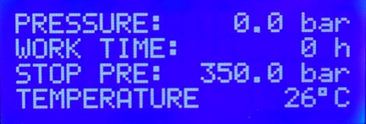The maximum pressure can be changed directly from the HOME screen alongside.

From the HOME screen, press the PAGE button to continue with the setup pages compressor.

Press PAGE to proceed.

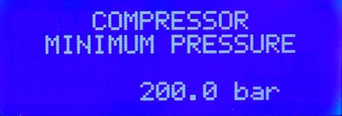

Set the restart pressure of the compressor, in the case of automatic mode. The pressure is adjustable from 0 bar up to 30 bar hysteresis below the set maximum pressure. (eg. press.max. 300 bar; press.min. 270 bar)

Press PAGE to proceed.

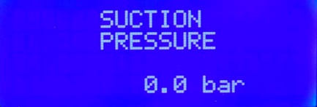

View the nitrogen pressure in the suction.

Press PAGE to proceed

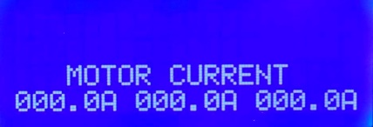

Real time display of the current absorbed by the compressor during use.

Press PAGE to proceed

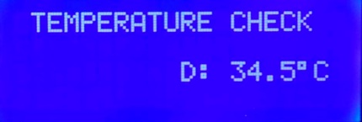

See the temperatures in the various stages of compression, only if enabled. They are called: A (stage 1), B (stage 2), C (stage 3), D (stage 4), E (option),

F (option).

Press PAGE to proceed

Displays the remaining time to service.

Press PAGE to return to the HOME page.

PARAMETERS

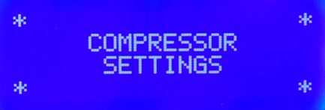

To enter in the parameters, keep pressed the keys of the ARROWS and press PAGE.



SETTINGS

Adjustment of the backlight

Press PAGE to proceed



Adjusting the display contrast

Press PAGE to proceed



Select your preferred language: ITALIAN, ENGLISH, FRENCH, GERMAN

Press PAGE to proceed

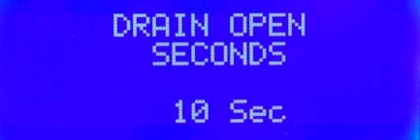

Set the seconds for time automatic condensate discharge open.

(Model Booster 5 second)

Press PAGE to proceed

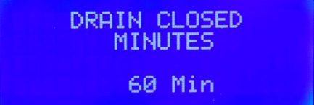 Set the seconds for time automatic condensate discharge closed.

(Model Booster 60 minutes)

Press PAGE to proceed



Select the unit of measurement for pressure: BAR, PSI, MPA

Press PAGE to proceed

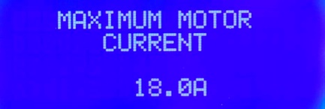

Set the maximum current absorbed by the electric motor. If absorption Ampere too high, the picture shows the corresponding alarm and stops the compressor.

Press PAGE to proceed

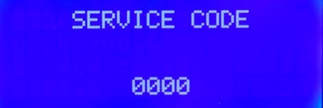

Enter a code for the protection of the set parameters.

Press PAGE to proceed

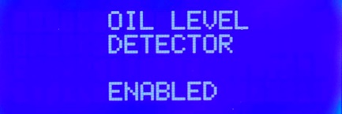

Enable or disable the automatic oil level. In case of the presence sensor, the display displays the warning of the presence oil, in case of too low level of oil.

Press PAGE to proceed.

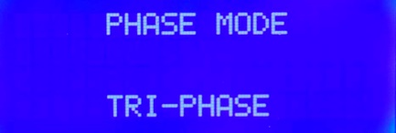

Set the type of power supply line: PHASE, SINGLE PHASE-PHASE, MODE 'DEMO (for exhibitions).

Press PAGE to proceed.

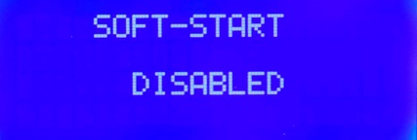

Setting to enable soft-start. And possible to integrate the module soft-start, the soft start of the electric motor. You have to enable the function to enable the start of the module.

Press PAGE to proceed

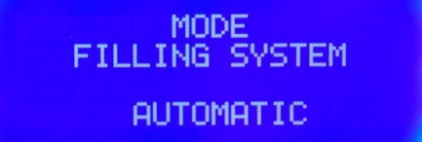

Set the mode AUTOMATIC or MANUAL to use the compressor. In automatic mode, the compressor will restart automatically under some pressure.

Press PAGE to proceed

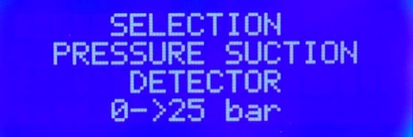Set the type of pressure transducer we installed on the compressor

(Booster model set 0-25 bar like in the picture)

Press PAGE to proceed

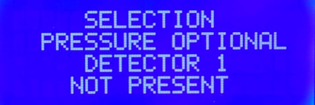

Select the pressure transducers optional, and eventual alarm threshold pressure. Up to 6 sensors simultaneously.

(standard without transducers optional)

Press PAGE to proceed

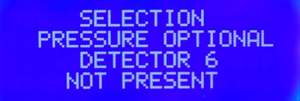

Set the pressure alarm of each transducer, which generates an alarm in case of over pressure. An alarm is generated even in case of accidental breakage of the cable or of the transducer.

Press PAGE to proceed.

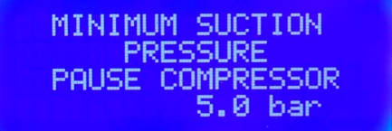

Set the minimum pressure of nitrogen input to the stand-by of the compressor in automatic mode. The compressor, below this threshold, it will put on stand-by waiting for sufficient pressure.

Press PAGE to proceed

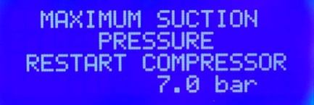

Set the pressure of nitrogen input for restarting the compressor from the stand-by mode. Once you get to the set threshold, the compressor will restart automatically

Press PAGE to proceed

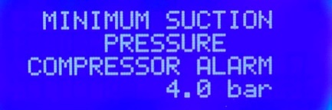

Set the threshold of the minimum pressure of compressor alarm. If the inlet pressure falls below this threshold, the compressor stops and the display shows the alarm LOW PRESSURE INLET

Press PAGE to proceed

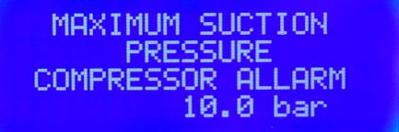

Set the threshold of maximum pressure alarm compressor. If the input pressure exceeds this threshold, the compressor stops and the display shows the alarm HIGH PRESSURE INPUT

Press PAGE to proceed

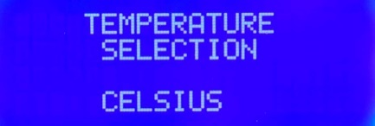

Select the temperature display: CELSIUS, FAHRENAIT

Press PAGE to proceed

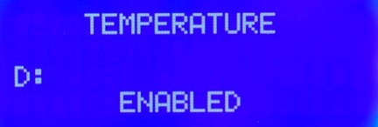Enable the temperature sensor or temperature sensors. There are up to 6 temperature sensors: A, B, C, D, E, F. In case of accidental breakage of the cable connection, you receive a warning indicating the probe temperature that creates the problem.

Press PAGE to proceed.

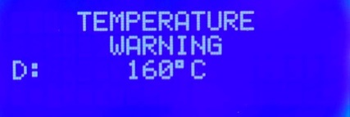Set the alarm threshold temperature applied. E 'can view this screen, only if the probes are enabled. Otherwise you will not see any pages. If you reach the maximum temperature, the compressor stops and the display shows HIGH TEMPERATURE ALARM.

Press PAGE to proceed

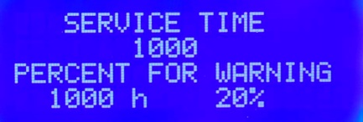Service time is intended to alert the operator that the machine needs a service, and when there is 20% of the time after the service, the display alerts the operator with a message, without blocking the compressor

Press PAGE to proceed



Once the service, you enter this page and hold the RESET button to reset the hours of service and restarting the count.

Press PAGE to proceed

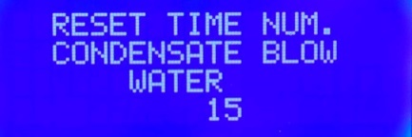

We check the total number of discharges condensate, to monitor cycles

Depressurization of the filter and of the components under pressure

Press PAGE to proceed



Set the maximum pressure set by the user. Above this pressure you can not go from the pages of initial view.

This pressure should only be changed by specialists Nardi Compressors.

Press PAGE to proceed



Enable remote control board compressor.

Press PAGE to proceed

Now all the parameters are set.

TO SAVE THE PARAMETERS HOLD THE KEY PAGE UNTIL YOU COMPARE THIS SCREEN.

YOU SELECT AND PRESS THE PAGE.

Now the parameters are saved.

Now we set user parameters.

**ALARM DISPLAY:**

The control panel can generate various alarms, when normally these are generated are due to the passing of set values ​​by NARDI COMPRESSORI (limits) or to a signal sent by the various components positioned at key points of the compressor. For each alarm, the display will show the message that indicates the problem, the red LED will light up to "GENERAL ALARMS", will send a beep and the compressor turns off automatically.

Because of the high precision of the control panel can generate an alarm very easy for example to a power surge, then you should press the "RESET" button and check if the alarm persists for a second time.

In the case where the same alarm persists, you should contact your local dealer and report the problem.

The alarms that may be generated are the following:

SEQUENCE PLASE OR FAILURE: Indicates that the motor and connected wrong (rotates in reverse).

OVER CURRENT MOTOR: Indicates an electrical current abnormal.

SERVICE TIME ALERT: This is to report that makes 200 or 100 hours must be done a service.

TIME SERVICE / MAINTENANCE NEED: Indicates that you need to do maintenance.

OVER TEMPERATURE COMPRESSOR Indicates that the compressor temperature is too high.

TEMPERATURE SENSOR BROCKEN NOT CONNECTED ON: Indicates that the temperature sensor is damaged or not connected.

PRESSURE SENSOR NOT CONNECTED BROCKEN ON: Indicates that the pressure sensor is damaged or not connected.

OIL LEVEL: This alarm indicates that the oil level is low.ALARMS”

**7 MAINTENANCE AND SERVICE COMPRESSOR**

**7.01 OPERATION OF MAINTENANCE*:***

**Because the machine is maintained in an efficient, needs a periodic assistance that, in addition to longer life, will keep its performance constant and efficient.**

**During his work cycles the compressor requires regular maintenance that will be performed by technicians trained by NARDI COMPRESSORS.**

**If this was not done by our technicians, is very important to follow the guidelines of the sheet of coupons in all its parts.**

**In the following paper we will find the scheduled maintenance operations to follow based on the hours of work done by the compressor.**

**It 'very important to record any maintenance performed on the compressor, in order to have a historic materials replaced, with the date of the day of service, the working hours of the compressor up to that point and the signature of the technician who worked on machine.**

 **IMPORTANT: All maintenance operations must be carried out by the technical staff NARDI COMPRESSORS or by qualified personnel.**

**IMPORTANT: All maintenance operations must be performed at machine switched off and the plug disconnected**

**7.02 LUBRIFICATION SYSTEM:**

The compressors NARDI COMPRESSORI haVE two different lubrication systems: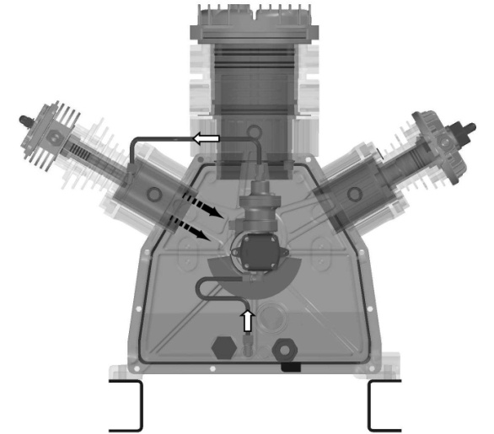

• Splash lubrication: This type of lubrication

takes place in a mechanical way with the movement of the connecting rods.

At their lower ends have a tang that in the rotation

it goes to dip into the oil at high speed causing a

spray that goes to lick the cylinders and the crankshaft assembly.

• Forced lubrication: This type of lubrication occurs through

a gear pump that takes power directly from the tree.

The oil sucked from the lowest point of the case is pumped and

filtered by a filter micronic and is sent to the piston guide last

stadium. In his motion goes to spray oil on all sides

movement.

**7.03 OIL:**

The oil is a component important for the life of the compressor in time. The NARDI COMPRESSORS has studied in detail the machine so that it has a large capacity in the hot oil and filtering it. On the case was screwed a magnet to attract all the metallic impurities that are deposited on the bottom.

We recommend the use of oil-specific NARDI COMPRESSORS, a special oil, designed and tested specifically for this machine.

Oil characteristics:

• Minimodeposito

• Effect anti-carbonizzante

• Excellent anti-corrosion properties

• Adaptation physiological and toxicological

**7.04 OIL CHANGE :**

The steps for oil changes are as follows:

• Make sure you have enough oil to run

change.

• Turn on the compressor for 15-20 minutes to allow

Heat the oil and make it more fluid.

• Remove the filler plug together with the oil breather extension.

• Remove the oil drain plug and before opening the tap

make sure you have a container.

• Close the drain valve and replace the cap.

• Pour the oil slowly from the cap load.

• Make sure that the maximum (MAX). Do not exceed this

level.

• Close the filler cap.

**7.05 CHANGE OIL TYPE:**

To avoid serious damage to the compressor when changing the type of oil, you need to follow closely the following measures:

• Follow the steps on the oil change Cap. 7:05.

• Change or clean all parts that have old oil.

• After 10 hours of compressor operation check if there is contamination.

• If the oil has been contaminated cater to execute another change.

• Do not mix different types of oil and use the same.

**7.06 CHANGE OIL FILTER:**

The steps for changing the oil filter are as follows (this operation is to be performed at every oil change)

• Unscrew the union nut that secures the oil feed pipe sul cilindro con una chiave da 14mm e sbloccarlo.

• Unscrew the four screws of the tank filter holder with a Phillips screwdriver.

• Lift the cap oil tank with the hose and remove the filter.

• Check if you want to change the O-ring of the oil tank cap.

• Close, turn on the compressor and make sure not leaking oil.

**7.07 OIL ALARM:**

When the oil level drops below the minimum threshold, an alarm is generated

visual and sound, with a message on the display alerts the operator that the scarcity

of oil in the compressor casing.

It s need to top up the oil to the compressor, as described above, until

to the maximum level. Press "RESET" button on the front panel, so as to reset the alarm and then "START" to share with charging.

In the event that, within a short time, the alarm is persistent oil level, must call a technician who controls the possible fault.

**7.08 INTERMEDIATE SEPARATOR:**

Within them there are filter elements that must be changed periodically.

The operations to be performed for the change of the filter elements are the following:

• A compressor off, depressurize the separators

through the condensate drain.

• Unscrew the lower part of the separators.

• Unscrew the filter element and replace it with the new one.

• Clean the bottom of the inside with a damp cloth

and check that there is no corrosion.

• Replace the O-ring seal.

• Replace the filter with force.

If used at a pressure higher than 300 bar, the separators intermediate

should be replaced after 10,000 hours.

**7.09 SOLENOID VALVES:**

The machine is built with the safety key, such as the solenoid valve in the suction, which opens the passage of the intake gas only with the compressor on, and closes again when the compressor is switched off or has finished charging.

The solenoid valve of the exhaust gas, however, works on the contrary, closing the exhaust passage while the compressor is working, and opens the outlet immediately after turning off of the latter, while leaving the remaining gas in the various stages of compression and emptying the rest of the residual gas in the various parts of the compressor.

The discharge oil / condensate is programmed to a cycle of about 15 minutes of usage and 6 seconds of oil drain.

**7.10 MAX PRESSURE AND INLET PRESSURE TRANDUCER:**

To ensure the proper compressor suction, place the transducer at the compressor, check the pressure in the suction and communicates to the control panel if the pressure is adequate or too low or too high. If the inlet pressure were to be too low or too high, the electronic control panel general alarm as described below

The maximum pressure transducer instead, is located at the outlet of the compressor, and communicates with the electronic control panel transmitting the actual pressure of the gas outlet, visible on the main page of the display.

In the case where the transducer is damaged, the display generates an alarm as described below. You should immediately call a technician who will replace the piece.

***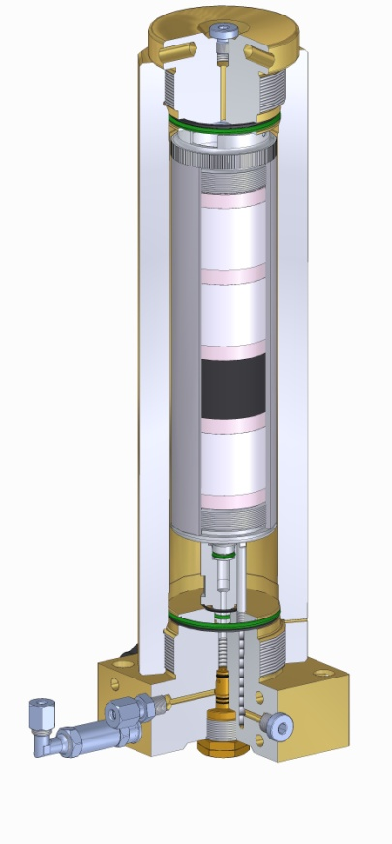*7.11 FILTER FOR NITROGEN :**

The molecular sieve filter is used to remove the oil residues that have passed the intermediate separators. The system of operation of the filter is not mechanical but chemical, with materials that absorb the oil particles making the nitrogen even cleaner from oily residues.

The filter has two safety systems. The first consists in a hole on the filter body which is closed when the cartridge and inserted. Its importance is that it makes it impossible for the operation of a dive shop in the absence of the cartridge. The second safety system is a milling on the thread of the filter body. In the event that it be accidentally unscrewed the upper part without depressurizing the compressor, this slit creates a discharge path of the nitrogen that is located inside it.

The life of the filter components consists of the number of work cycles in that, the base and the upper body, undergo dynamic loads due to the pressure and depression of the filter. The NARDI COMPRESSORS calls for every 500 hours of work to be made an 'inspection by a technician and exceeded the 8000 cycles at 300 bar or 21,000 cycles at 225 Bar is replaced the complete filter. With a rough calculation of 4 cycles per hour to 300 bar the filter should be changed after 2000 hours of work while 225 Bar after about 5000 hours.

**7.12 CARTRIDGE FOR NITROGEN :**

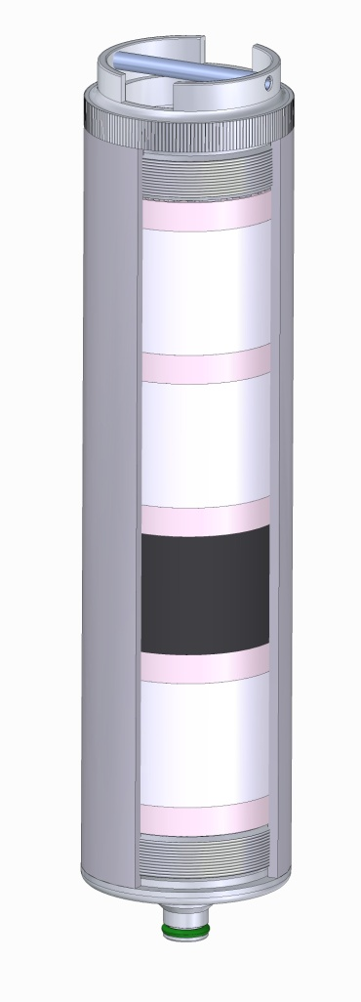

The operations for the replacement of the cartridges are the following:

• Vent all the filtering system before performing any operation.

• Unscrew the upper filter body and handle it carefully without him take shots.

• Remove the cartridge.

• Wipe the inside of the new filter.

• Screw the new cartridge.

• Check the O-ring of the filter, change it if damaged O-ring original.

• Screw the upper filter body with the hands (do not use tools).

The life of the cartridge depends on many parameters such as temperature, flow rate of the nitrogen compressor, size of the cartridge itself, etc ..

  The new cartridge should remain in dry environments.

It comes in a vacuum pack that must remain closed until it is used.

The cartridge should always be changed if passed an idle time of 10 months mounted on the compressor. You have to use only materials provided by NARDI COMPRESSORS.

Users who want to regenerate the cartridges must be well prepared to do this and you should only use material NARDI COMPRESSORS.

The tables supplied by us can be used with constant parameters and with new cartridges supplied by NARDI COMPRESSORS unregenerate.

**7.13 MAINTENANCE VALVE:**

This type of valve has the purpose of maintaining constant pressure in the final filter.

In this way, it improves the quality of the nitrogen and the life of the cartridge.

When the compressor, the valve remains closed up to bring the whole system to about 150 bar, and only then opens.

The valve is calibrated by NARDI COMPRESSORS and needs no further calibration.

**7.14 HEAD AND COMPRESSION VALVE:**

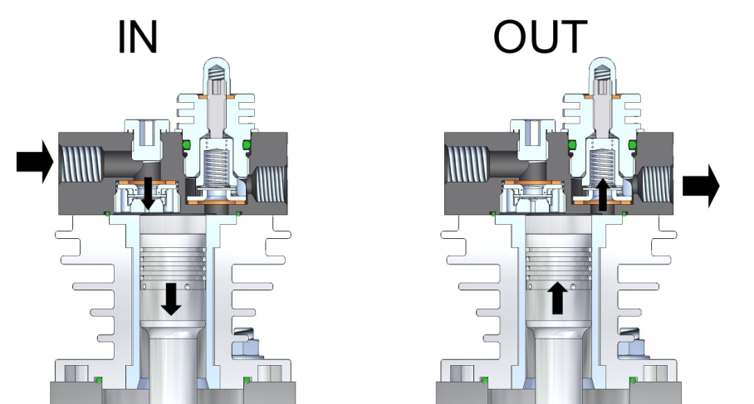The intake valves or exhaust are or plates or lamellae. Normally the first stage it is constituted by a reed valve and they will open and close according to the flow of air that is created by the moving piston.

The system operation is the same for all stages but change the size of the valves and of the plates.

It 'important that valve replacement and cleaning of them is performed by trained personnel.

The rules to be followed for recovering are the following:

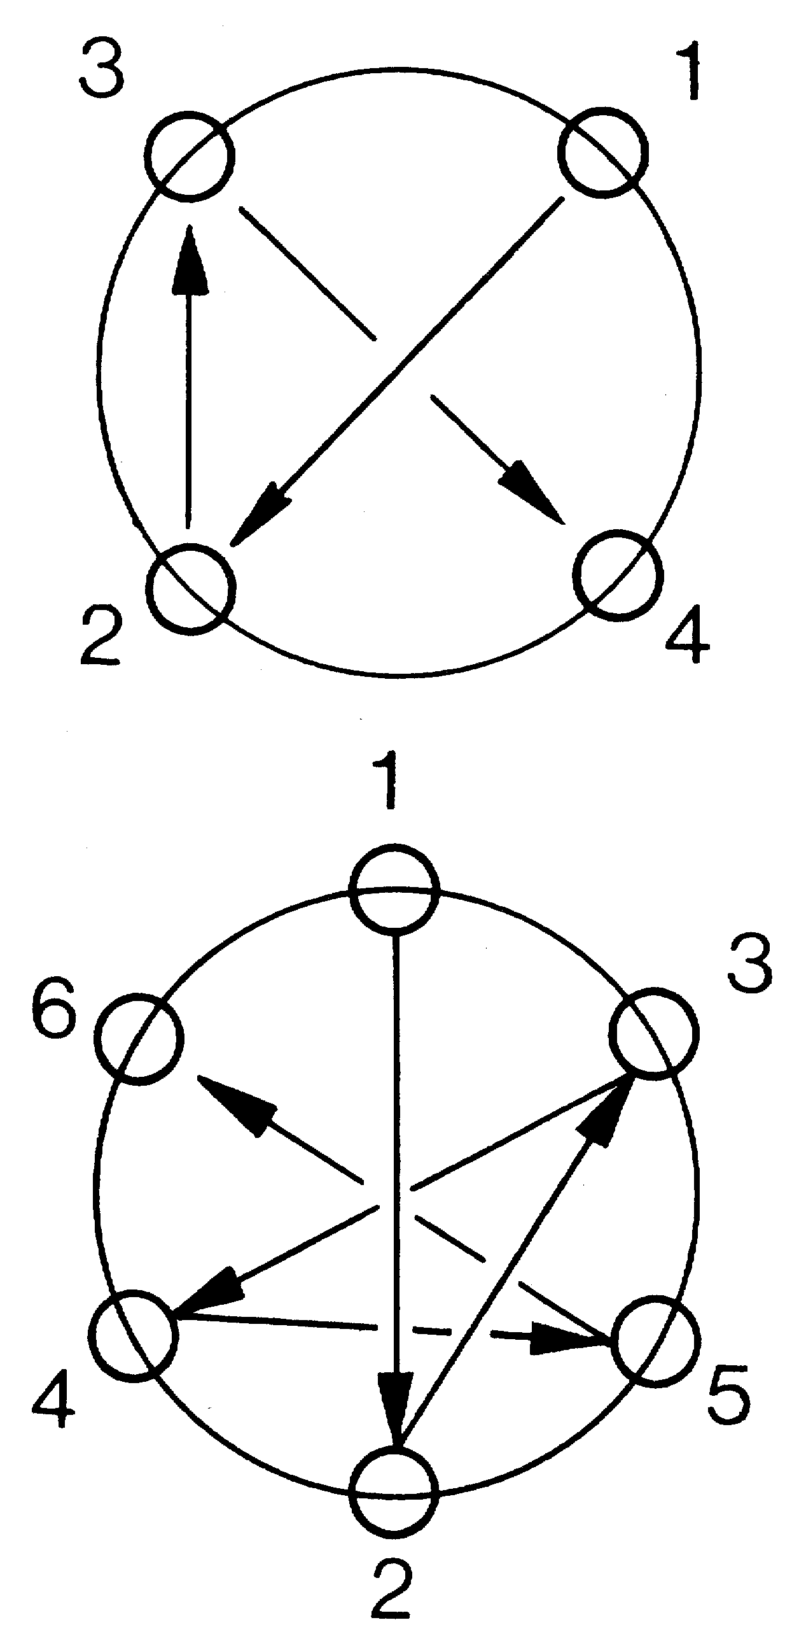

• Replace all the parts that make up the valve and not just some details.

• Carefully clean the valves and remove all carbon deposits without scratching the valve.

• Be careful when the sequence of the components are reassembled.

• If the scratches are present on the valve due to wear, change the valve.

• Replace o-ring seal.

• Pay attention to the figure appears indicating the closing sequence of the screws of the head.

• After performing the maintenance of valves, turn on the compressor for 30 - 40 minutes, turn it off and check the closing of the screws and the grains that compress the exhaust valve / flow cylinder side.

• The valves can be inspected every 500 hours of work.

• After 1000 hours of work should be replaced in all their components.

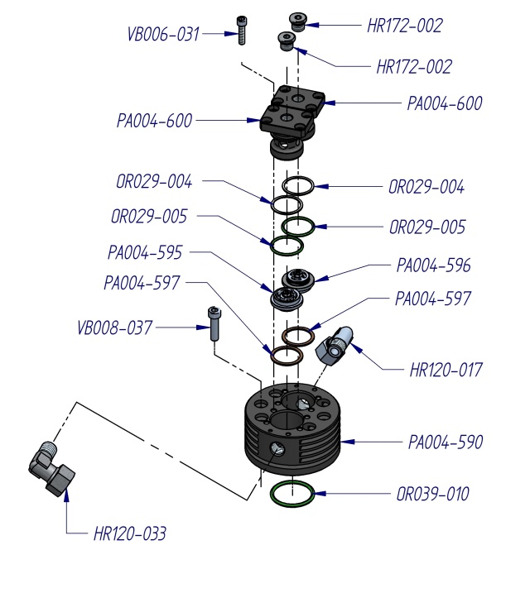**7.15 VALVE REPLACEMENT - FIRST STAGES:**

The steps for the replacement or cleaning of the valve are the following:

• Disconnect the cooling tubes from the fittings.

• Remove the screws and detach completely from the cylinder head.

• Fix the head in a vice.

• Unscrew the valve bodies (one of these bodies must be unscrewed with a particular key to require to NARDI COMPRESSORS).

• Clean and remove all debris.

• If signs of wear, change the worn parts.

• Replace all components with the same sequence by changing the seal rings.

• On the lower part of the head there are three points that need to be incised with a punch after it has set the valve.

• Test the operation of the valve by blowing compressed air in the flow direction.

• Check the O-ring seal and replace if damaged.

• Attach the head to the cylinder.

• Secure the cooling pipes.

**7.16 VALVE REPLACEMENT - SECOND STAGES:**

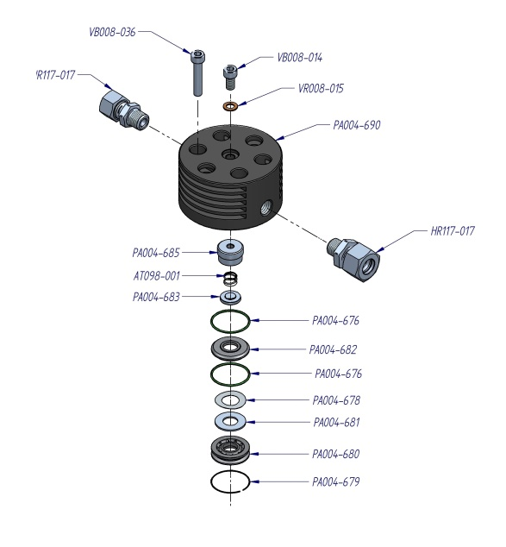

The steps for the replacement or cleaning of the valve are the following:

• Disconnect the cooling tubes from the fittings.

• Remove the screws and detach completely from the cylinder head.

• Fix the head in a vice.

• Unscrew the valve bodies (one of these bodies must be unscrewed with a particular key to require to NARDI COMPRESSORS).

• Clean and remove all debris.

• If they are worn to change the worn parts.

• Replace all components with the same sequence, changing the seal rings.

• On the lower part of the head there are two points that should be engraved with an awl after it has set the valve.

• Test the operation of the valve by blowing compressed air in the flow direction.

• Check the O-ring seal and replace if damaged.

• Attach the head to the cylinder.

• Secure the cooling pipes.

**7.17 MAINTENANCE OF OIL SEPARATOR:**

The compressor is equipped with a filter cartridge for the oil vapors that are formed in the casing of the pump unit of the compressor. These vapors, before they are expelled and released into the air, are held by a cartridge disoleatrice, deposited on the outside of the latter. Thanks to its particular conformation, the oil deposited on the outside of the cartridge back into the case at the time of stops of the compressor, thus recovering the vaporized oil.

This cartridge should be replaced annually or after 500 h of work.

In the event that is not replaced, on the crate was placed a safety valve 0.5 Bar, which serves to not create an excessive pressure in the casing of the pump unit, while preserving the life of the O-rings and oil seals.

**7.18 SAFETY VALVE:**

These valves are critical to the safety of the operator and the compressor.

Valves are calibrated to a certain pressure, which discharge the nitrogen in the air in the case of faults or malfunctions.

Each cylinder is equipped with a safety valve, and each valve has a calibration set different:

|  |  |
| --- | --- |
| SECURITY VALVE | MAX PRESSURE |
| 1° STAGE | 85 BAR |
| 2° STAGE | 350 BAR |



**NOT 'ALLOWED TO CHANGE THE PRESSURE CALIBRATION**

**NONE OF VALVE. ANY CHANGES CAN 'CAUSE SERIOUS INJURY AND**

**VOID THE WARRANTY !!**

**7.19 AUTOMATIC CONDENSATE DRAIN VALVE:**

The condensate drain and oil filters of the two separators and residual moisture of the final filter carbon, takes place simultaneously and in an automatic way, through a single exhaust system, which significantly lowers costs and greatly simplifies the operation.

Each 15 minutes (the time is set at the factory but you can reset it later as you prefer), the solenoid valve opens the flow of nitrogen for 5 seconds it takes to trigger the pistons connected to the separator filters and final filter.

The default parameters set at the factory are:

DRAIN CLOSED = 60 MINUTES (OFF)

DRAIN OPEN = 5 SECONDS (ON***)***

**7.20 SPECIAL WASTE DISPOSAL:**

The disposal of the components or the compressor must be done according to the rules in force in the country of installation.

|  |  |  |
| --- | --- | --- |
| ***PROBLEM*** | ***REASON*** | ***SOLUTION*** |
| The compressor will not turn on | • Electric current absent | • Control power line |
|  | • Checking fuses | • Sostiuzione defective fuse |
|  | • Electric current is too low | • Control power line |
| The compressor discharge oil from the drain gas back | • Shallow gas flow in the suction | • Increase the range |
|  | • Pressure too close to the minimum allowable suction | • Increase the pressure of the suction gas |
|  | • Elastic band piston route | • Replace the piston ring broken |
| The electric motor does not work |  | • Reverse the motor phases |
|  | • Problems with the electrical circuit | • Check fuses |
|  | • No phase current | • Check that there is sufficient electrical current |
|  | • Electric motor failure | • Check that power is coming to the engine |
|  |  |  |
| The speed of rotation and the flow rate decrease.  Noise belt slipping. | • The current to the motor is insufficient | • Check that there is sufficient electrical current |
| • Check the electric motor |
|  | • Immediately lower the inlet pressure |
|  |  |
| The flow rate decreases (no lowering of rotation) | • The belt slips | • Check the belt tension |
| • The inlet pressure is too high, the opening of the solenoid | • Belt Replacement |
|  |  | • Tighten fittings |
|  | • Loose fittings | • Replace the seals |
|  | • Seals worn | • Replacing or cleaning filter |
|  | • Suction filter clogged | • Replace the piston rings |
|  | • Piston rings worn | • Check the suction pipe |
| Does not reach the maximum pressure | • Extension suction clogged | • Replacing or cleaning valves |
|  | • Valves not working | • Increase the suction capacity |
|  | • Shallow gas flow in the suction  • Piston rings worn | • Replacing piston rings worn |
|  | • Replace worn piston |
|  | • Piston overly consumed | • Cleaning safety valve |
|  | • Premature opening of the safety valve | • Safety valve calibration |
| The safety valve of an intermediate stage loses air |  | • Replace safety valve |
|  |  |
|  | • Problems pressure next stage |
|  | • Pressure stage too high | • Cleaning safety valve |
|  | • Premature opening of the safety valve | • Safety valve calibration |
| he compressor overheats |  | • Replace safety valve |
|  | • Valves dirty or not working | • Replacing the intake valves cylinders |
|  |  | • Invert the phases of the electric motor |
|  | • Direction of rotation opposite | • Prolonged exposure to the sun |
|  | • Step cooling air obstructed | • Checking, cleaning or replacing valves |
| Excessive oil consumption | • Closing the valves incorrect | • ° T too high ambient (+45 ° C Max) |
|  |  | • Check the cooling air passages |
|  |  | • Replacing piston rings worn |
|  | • Piston rings worn | • Replace worn piston |
|  | • Piston overly consumed | • Clean suction filter |
| The compressor will not turn off automatically | • Clogged suction filter | • Replace suction filter |
| • Shallow gas flow in the suction | • Increase the gas flow in the intake |
|  |  |
|  |  | • Cleaning safety valve |
|  |  | • Safety valve calibration |

|  |  |  |
| --- | --- | --- |
| NARDI LOGO SESAMO | **SPARE PARTS**  **BOOSTER 55 - 350**  ***Driving gear*** | BOO001-045 Rev.00  Date 12/02/2011 |

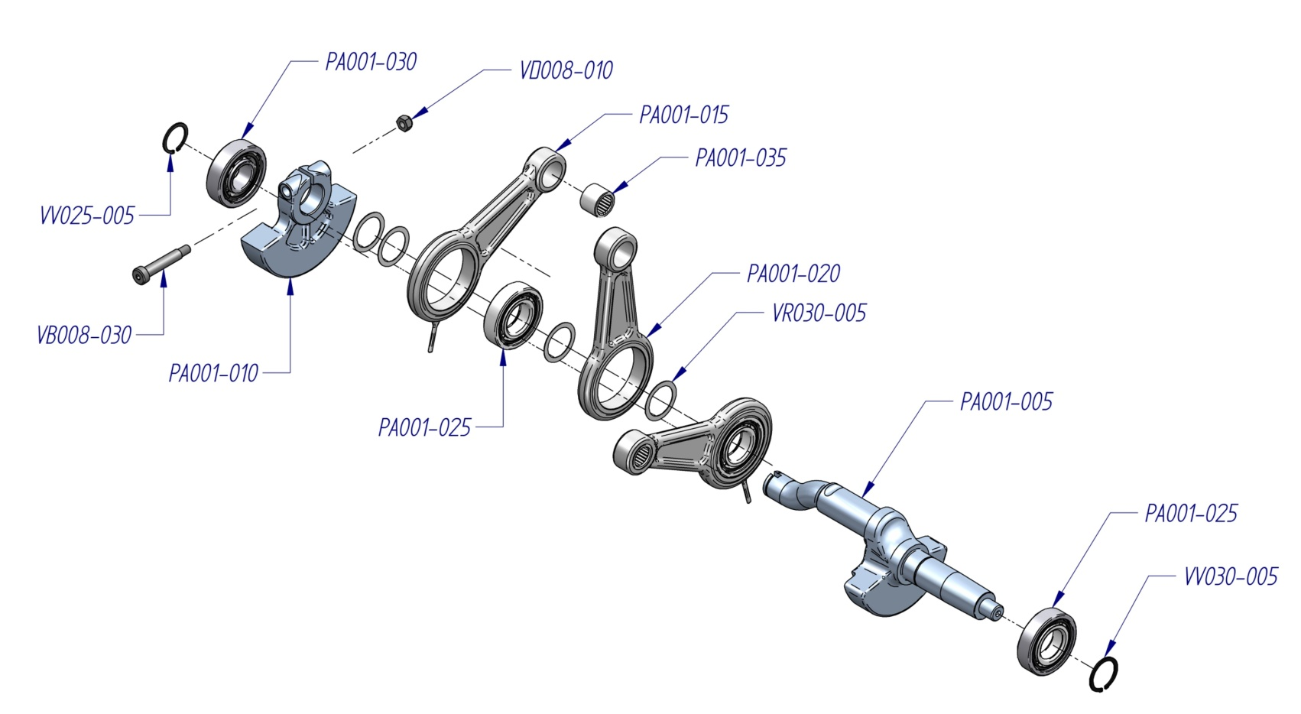

|  |  |  |  |  |  |  |  |  |
| --- | --- | --- | --- | --- | --- | --- | --- | --- |
| ***CODE*** | ***DESCRIPTION*** |  | ***CODE*** | ***DESCRIPTION*** |  | ***CODE*** | ***DESCRIPTION*** |  |
| **PA001-005** | *Shaft* |  | **PA001-025** | *Roller bearing* |  | **VD008-010** | *Nut* |  |
| **PA001-010** | *Counterbalance* |  | **PA001-030** | *Roller bearing* |  | **VR030-005** | *Washer* |  |
| **PA001-015** | *Connecting rod with oil thrower pin* |  | **PA001-035** | *Roller bearing* |  | **VV025-005** | *Safety ring* |  |
| **PA001-020** | *Connecting rod* |  | **VB008-030** | *Screw* |  | **VV030-005** | *Safety ring* |  |

|  |  |  |
| --- | --- | --- |
| NARDI LOGO SESAMO | **SPARE PARTS**  **BOOSTER 55 - 350**  ***Driving gear*** | BOO001-055 Rev.00  Date 12/02/2011 |

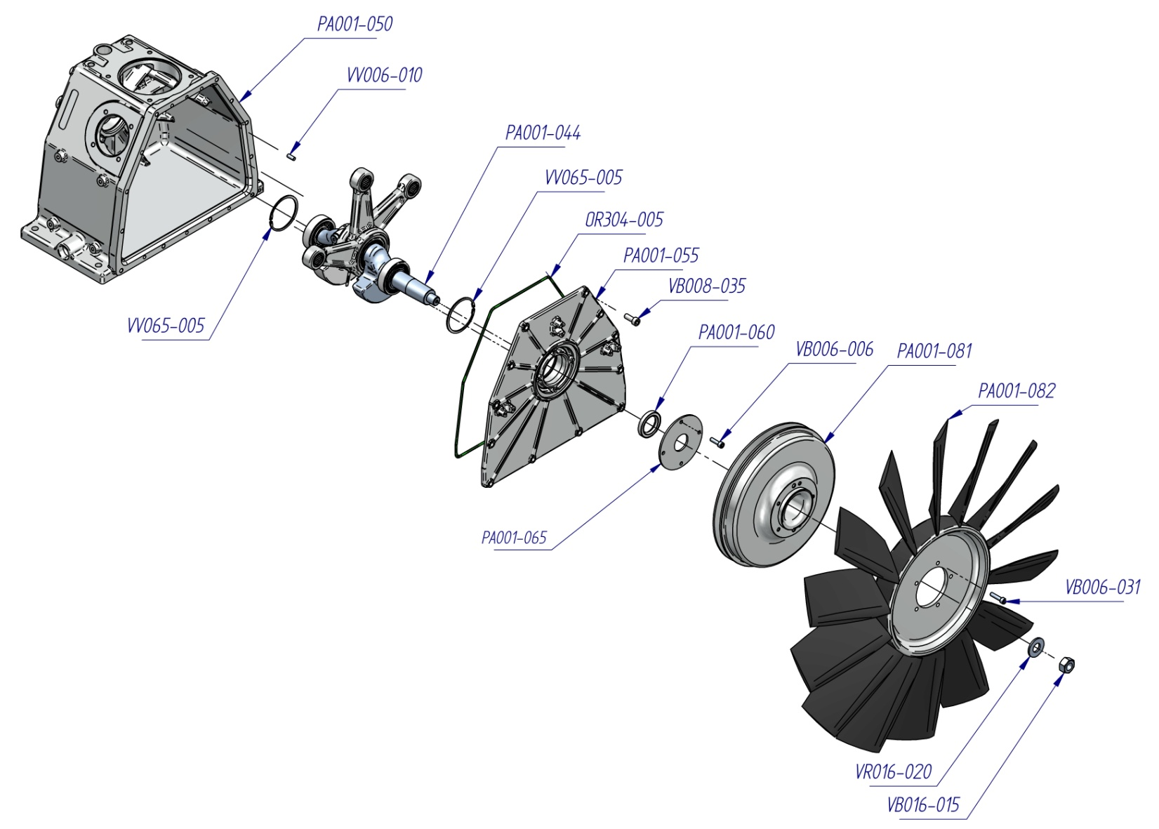

|  |  |  |  |  |  |  |  |  |
| --- | --- | --- | --- | --- | --- | --- | --- | --- |
| ***CODE*** | ***DESCRIPTION*** |  | ***CODE*** | ***DESCRIPTION*** |  | ***CODE*** | ***DESCRIPTION*** |  |
| **OR304-005** | *O-ring* |  | **PA001-065** | *Oil seal flange* |  | **VB008-035** | *Screw* |  |
| **PA001-044** | *Shaft complete of connecting rod* |  | **PA001-081** | *Pulley* |  | **VD016-015** | *Nut* |  |
| **PA001-050** | *Compressor crankcase* |  | **PA001-082** | *Fan* |  | **VR016-020** | *Washer* |  |
| **PA001-055** | *Closing crankcase flange* |  | **VB006-006** | *Screw* |  | **VV006-010** | *Pin* |  |
| **PA001-060** | *Oil seal* |  | **VB006-031** | *Screw* |  | **VV065-005** | *Safety ring* |  |

|  |  |  |
| --- | --- | --- |
| NARDI LOGO SESAMO | **SPARE PARTS**  **BOOSTER 55- 350**  ***Crankcase whit accessories*** | BOO001-062 Rev.02  Date 02/07/2015 |

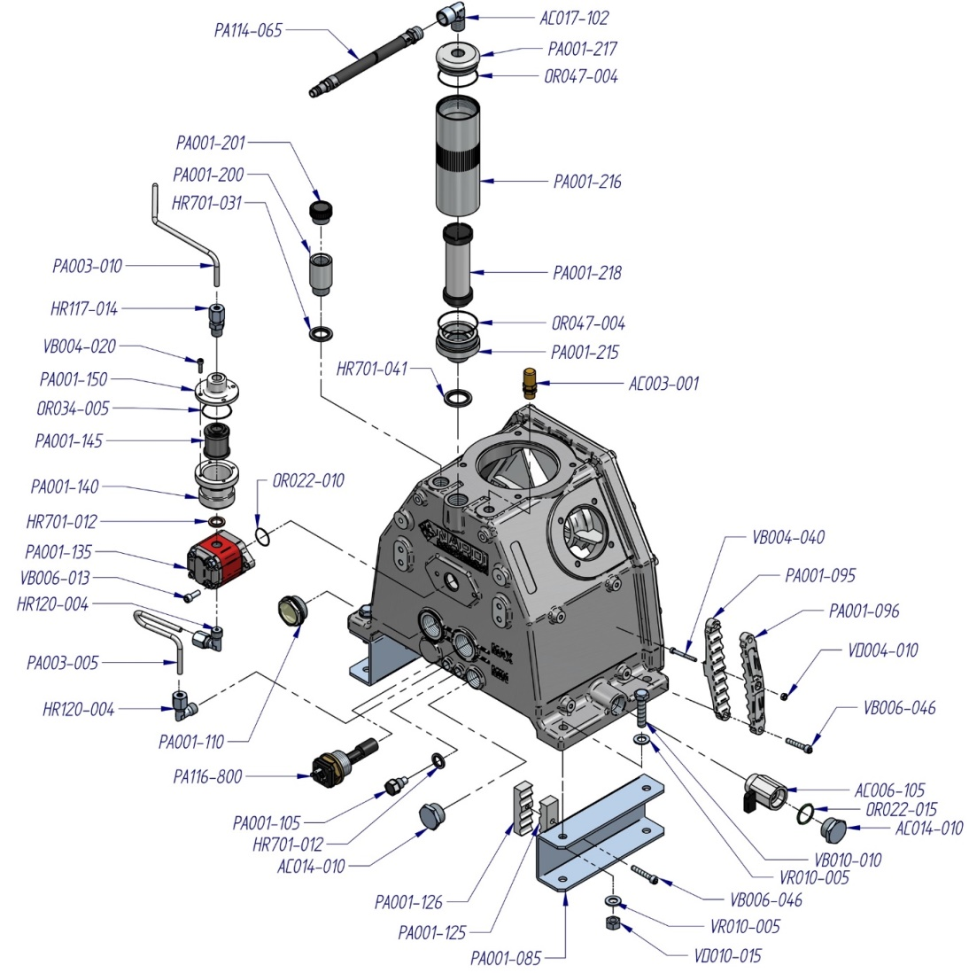

|  |  |  |  |  |  |  |  |  |
| --- | --- | --- | --- | --- | --- | --- | --- | --- |
| ***CODE*** | ***DESCRIPTION*** |  | ***CODE*** | ***DESCRIPTION*** |  | ***CODE*** | ***DESCRIPTION*** |  |
| ***AC003-001*** | *Safety valve* |  | **PA001-096** | *Support cooling tube* |  | **PA003-005** | *Tube oil pump* |  |
| ***AC006-105*** | *Ball valve* |  | **PA001-105** | *Magnetic plug* |  | **PA003-010** | *Tube oil pump* |  |
| **AC014-010** | *Closure plug* |  | **PA001-110** | *Visual oil level plug* |  | **PA114-065** | *Tube drain* |  |
| **AC017-102** | *Pipe filling “L”* |  | **PA001-125** | *Support cooling tube* |  | **PA116-800** | *Oil alert* |  |
| **HR117-014** | *Pipe fitting* |  | **PA001-126** | *Support cooling tube* |  | **VB004-020** | *Screw* |  |
| **HR120-004** | *Pipe fitting “L”* |  | **PA001-135** | *Oil pump* |  | **VB004-040** | *Screw* |  |
| **HR701-012** | *Washer* |  | **PA001-140** | *Oil filter holder chamber* |  | **VB006-013** | *Screw* |  |
| **HR701-031** | *Washer* |  | **PA001-145** | *Oil filter* |  | **VB006-046** | *Screw* |  |
| **HR701-041** | *Washer* |  | **PA001-150** | *Closure oil filter chamber* |  | **VB010-010** | *Screw* |  |
| **OR022-010** | *O-ring* |  | **PA001-200** | *Oil fitting pipe* |  | **VD004-010** | *Nut* |  |
| **OR022-015** | *O-ring* |  | **PA001-201** | *Plug* |  | **VD010-015** | *Nut* |  |
| **OR034-005** | *O-ring* |  | **PA001-215** | *Oil separator flange* |  | **VR010-005** | *Washer* |  |
| **OR047-004** | *O-ring* |  | **PA001-216** | *Oil separator body* |  |  |  |  |
| **PA001-085** | *Support compressor* |  | **PA001-217** | *Oil separator flange* |  |  |  |  |
| **PA001-095** | *Support cooling tube* |  | **PA001-218** | *Oil separator cartridge* |  |  |  |  |

|  |  |  |
| --- | --- | --- |
| NARDI LOGO SESAMO | **SPARE PARTS**  **BOOSTER 55 - 350**  ***2nd STAGE CENTRAL*** | BOO002-037 Rev.01  Date 12/02/2015 |

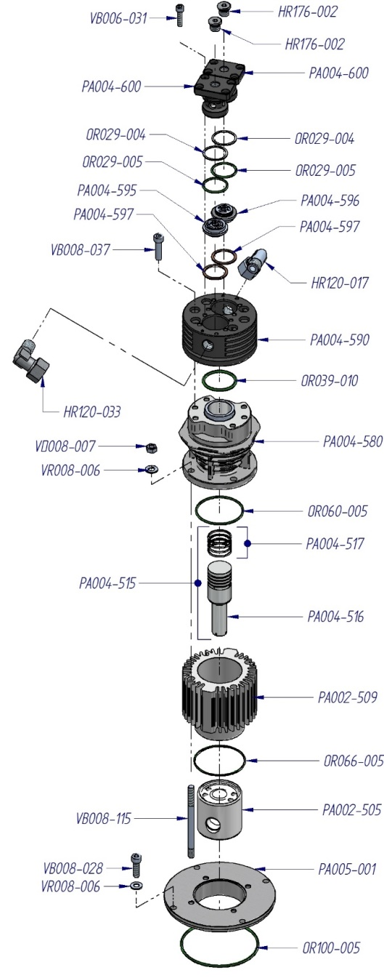

|  |  |  |  |  |  |  |  |  |
| --- | --- | --- | --- | --- | --- | --- | --- | --- |
| ***CODE*** | ***DESCRIPTION*** |  | ***CODE*** | ***DESCRIPTION*** |  | ***CODE*** | ***DESCRIPTION*** |  |
| **HR120-017** | *Pipe fitting “L”* |  | **PA002-509** | *Cylinder* |  | **PA005-001** | *Flange* |  |
| **HR120-033** | *Pipe fitting “L”* |  | **PA002-515** | *Complete piston with rings* |  | **VB006-031** | *Screw* |  |
| **HR176-002** | *Closure plug* |  | **PA002-516** | *Piston* |  | **VB008-028** | *Screw* |  |
| **OR029-004** | *O-ring* |  | **PA002-517** | *Set piston rings* |  | **VB008-037** | *Screw* |  |
| **OR029-005** | *O-ring* |  | **PA00 4-580** | *Cylinder* |  | **VB008-115** | *Screw* |  |
| **OR039-010** | *O-ring* |  | **PA004-590** | *Valve head* |  | **VD008-007** | *Nut* |  |
| **OR060-005** | *O-ring* |  | **PA004-595** | *Valve* |  | **VR008-006** | *Washer* |  |
| **OR066-005** | *O-ring* |  | **PA004-596** | *Valve* |  |  |  |  |
| **OR100-005** | *O-ring* |  | **PA004-597** | *Seal* |  |  |  |  |
| **PA002-505** | *Piston guide* |  | **PA004-600** | *Cover valve* |  |  |  |  |

|  |  |  |
| --- | --- | --- |
| NARDI LOGO SESAMO | **SPARE PARTS**  **BOOSTER 55 - 350**  ***2nd STAGE SIDE*** | BOO002-036 Rev.02  Date 02/07/2015 |

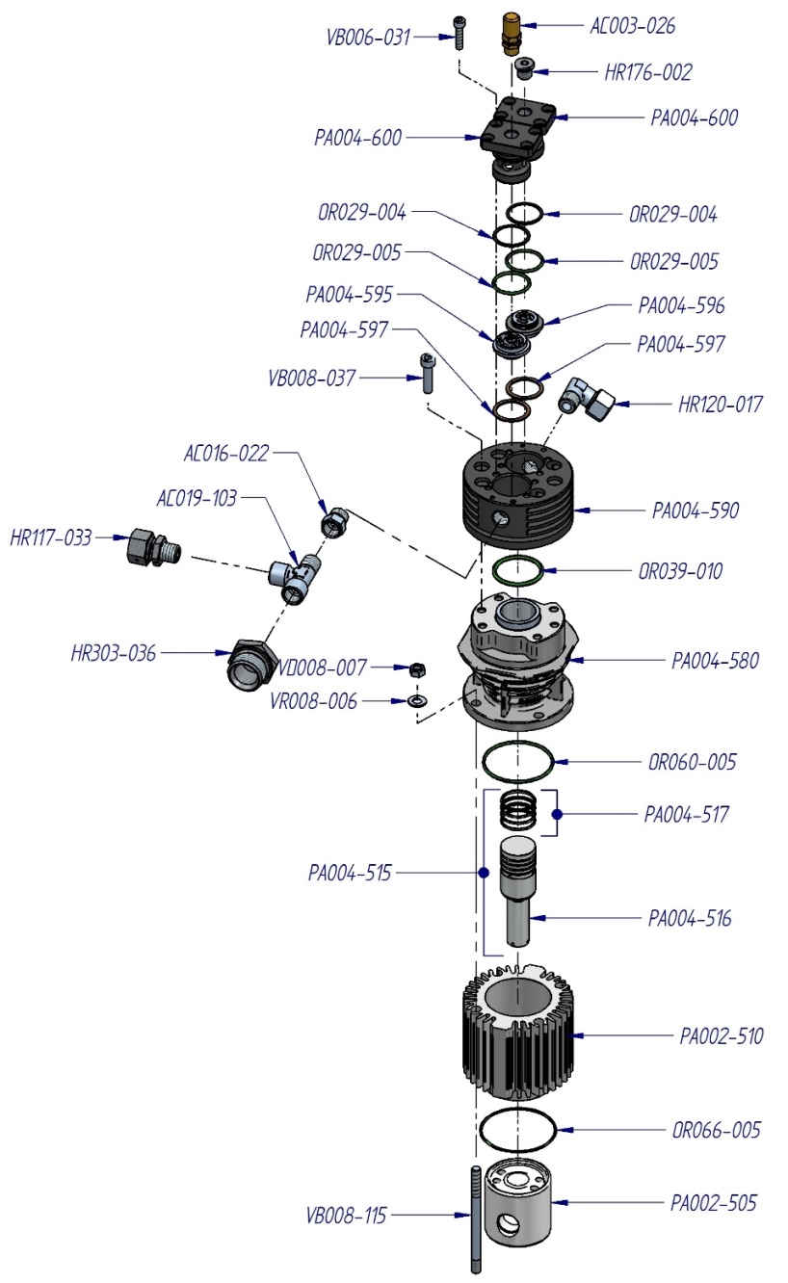

|  |  |  |  |  |  |  |  |  |
| --- | --- | --- | --- | --- | --- | --- | --- | --- |
| ***CODE*** | ***DESCRIPTION*** |  | ***CODE*** | ***DESCRIPTION*** |  | ***CODE*** | ***DESCRIPTION*** |  |
| **AC003-026** | *Safety valve* |  | **OR060-005** | *O-ring* |  | **PA004-596** | *Valve* |  |
| **AC016-022** | *Connection* |  | **OR066-005** | *O-ring* |  | **PA004-597** | *Seal* |  |
| **AC019-103** | *Pipe fitting “T”* |  | **PA002-505** | *Piston guide* |  | **PA004-600** | *Cover valve* |  |
| **HR117-033** | *Pipe fitting* |  | **PA004-510** | *Cylinder* |  | **VB006-031** | *Screw* |  |
| **HR120-017** | *Pipe fitting “L”* |  | **PA004-515** | *Complete piston with rings* |  | **VB008-037** | *Screw* |  |
| **HR176-002** | *Closure plug* |  | **PA004-516** | *Piston* |  | **VB008-115** | *Screw* |  |
| **HR303-036** | *Reduction* |  | **PA004-517** | *Set piston rings* |  | **VD008-007** | *Nut* |  |
| **OR029-004** | *O-ring* |  | **PA004-580** | *Cylinder* |  | **VR008-006** | *Washer* |  |
| **OR029-005** | *O-ring* |  | **PA004-590** | *Valve head* |  |  |  |  |
| **OR039-010** | *O-ring* |  | **PA004-595** | *Valve* |  |  |  |  |

|  |  |  |
| --- | --- | --- |
| Descrizione: NARDI LOGO SESAMO | **SPARE PARTS**  **BOOSTER 55 - 350**  ***Third Stage*** | BOO002-014 Rev.01  Date 03/06/2014 |

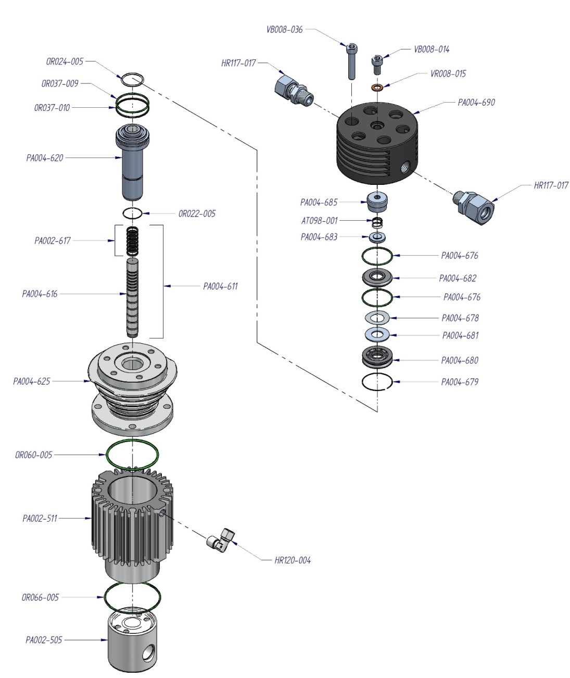

|  |  |  |  |  |  |  |  |  |
| --- | --- | --- | --- | --- | --- | --- | --- | --- |
| ***CODE*** | ***DESCRIPTION*** |  | ***CODE*** | ***DESCRIPTION*** |  | ***CODE*** | ***DESCRIPTION*** |  |
| **AT098-001** | *Spring* |  | **PA004-611** | *Complete piston with rings* |  | **PA004-683** | *Valve top* |  |
| **HR117-017** | *Pipe fitting direct* |  | **PA004-616** | *Piston* |  | **PA004-685** | *Suction valve* |  |
| **HR120-004** | *Pipe fitting “L”* |  | **PA002-617** | *Set piston rings* |  | **PA004-690** | *Valve head* |  |
| **OR037-009** | *O-ring* |  | **PA004-620** | *Cylinder’s pipe* |  | **VB008-014** | *Screw* |  |
| **OR037-010** | *O-ring* |  | **PA004-625** | *Cylinder* |  | **VB008-036** | *Screw* |  |
| **OR022-005** | *O-ring* |  | **PA004-680** | *Coupling pressure valve* |  | **VR008-015** | *Washer* |  |
| **OR024-005** | *O-ring* |  | **PA004-681** | *Pressure valve* |  |  |  |  |
| **OR060-005** | *O-ring* |  | **PA004-682** | *Top valve* |  |  |  |  |
| **OR066-005** | *O-ring* |  | **PA004-676** | *Special O-Ring* |  |  |  |  |
| **PA002-505** | *Piston guide* |  | **PA004-678** | *Special spring* |  |  |  |  |
| **PA002-511** | *Cylinder* |  | **PA004-679** | *Setger valve* |  |  |  |  |

|  |  |  |
| --- | --- | --- |
| NARDI LOGO SESAMO | **SPARE PARTS**  **BOOSTER 55 - 350**  ***Filter Separator and Drain valve*** | BOO005-010 Rev.01  Date 03/07/2015 |

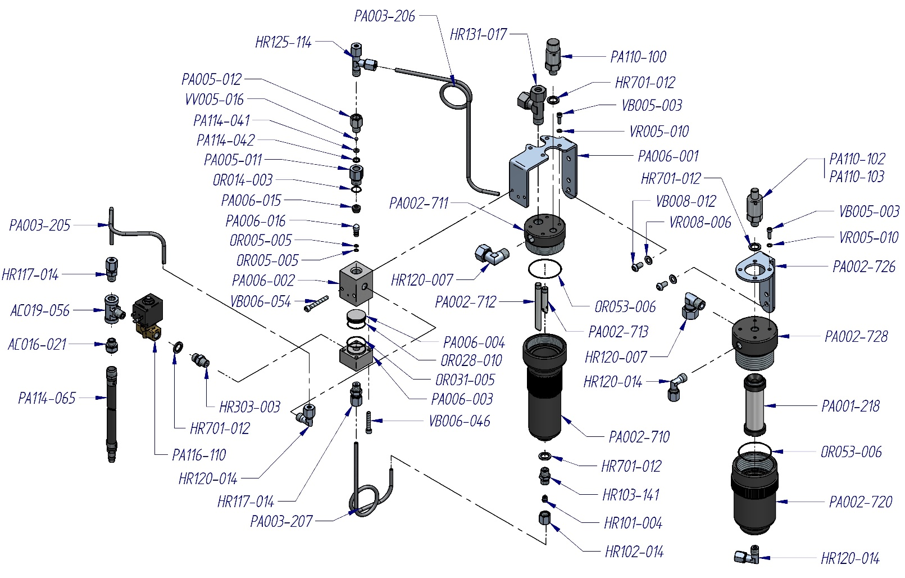

|  |  |  |  |  |  |  |  |  |
| --- | --- | --- | --- | --- | --- | --- | --- | --- |
| ***CODE*** | ***DESCRIPTION*** |  | ***CODE*** | ***DESCRIPTION*** |  | ***CODE*** | ***DESCRIPTION*** |  |
| **AC016-021** | *Reduction* |  | **PA002-710** | *Body filter separator* |  | **PA110-100** | *Safety valve* |  |
| **AC019-056** | *Pipe fitting “T”* |  | **PA002-711** | *Head filter separator* |  | **PA110-102** | *Safety valve PN 200 bar* |  |
| **HR117-014** | *Pipe fitting “L”* |  | **PA002-712** | *Tube separator* |  | **PA110-103** | *Safety valve PN 300 bar* |  |
| **HR101-004** | *Ogive* |  | **PA002-713** | *Tube separator* |  | **PA114-041** | *Reduction ring* |  |
| **HR102-014** | *Nut filling pipe* |  | **PA002-720** | *Body filter separator* |  | **PA114-042** | *Seal ring* |  |
| **HR103-141** | *Pipe fitting* |  | **PA002-726** | *Support filter separator* |  | **PA114-065** | *Tube drain* |  |
| **HR120-007** | *Pipe fitting “L”* |  | **PA002-728** | *Head filter separator* |  | **PA116-110** | *Solenoid valve* |  |
| **HR120-014** | *Pipe fitting “L”* |  | **PA003-205** | *Tube* |  | **VB005-003** | *Screw* |  |
| **HR125-114** | *Pipe fitting “T”* |  | **PA003-206** | *Tube* |  | **VB006-046** | *Screw* |  |
| **HR131-017** | *Pipe fitting “T”* |  | **PA003-207** | *Tube* |  | **VB006-054** | *Screw* |  |
| **HR303-003** | *Filling hose* |  | **PA005-011** | *Connection* |  | **VB008-012** | *Screw* |  |
| **HR701-012** | *Washer* |  | **PA005-012** | *Connection* |  | **VR005-010** | *Washer* |  |
| **OR005-005** | *O-ring* |  | **PA006-001** | *Support drain valve and filter separator* |  | **VR008-006** | *Washer* |  |
| **OR014-003** | *O-ring* |  | **PA006-002** | *Body drain valve* |  | **VV005-016** | *Sphere* |  |
| **OR028-010** | *O-ring* |  | **PA006-003**  **PA00** | *Base of body drain valve* |  |  |  |  |
| **OR031-005** | *O-ring* |  | **PA006-004** | *Piston drain valve* |  |  |  |  |
| **OR053-006** | *O-ring* |  | **PA006-015** | *Piston seal* |  |  |  |  |
| **PA001-218** | *Oil separator cartridge* |  | **PA006-016** | *Piston valve* |  |  |  |  |

|  |  |  |
| --- | --- | --- |
| NARDI LOGO SESAMO | **SPARE PARTS**  **BOOSTER 55 - 350**  ***Tube e cooler*** | BOO005-011 Rev.01  Date 03/07/2015 |

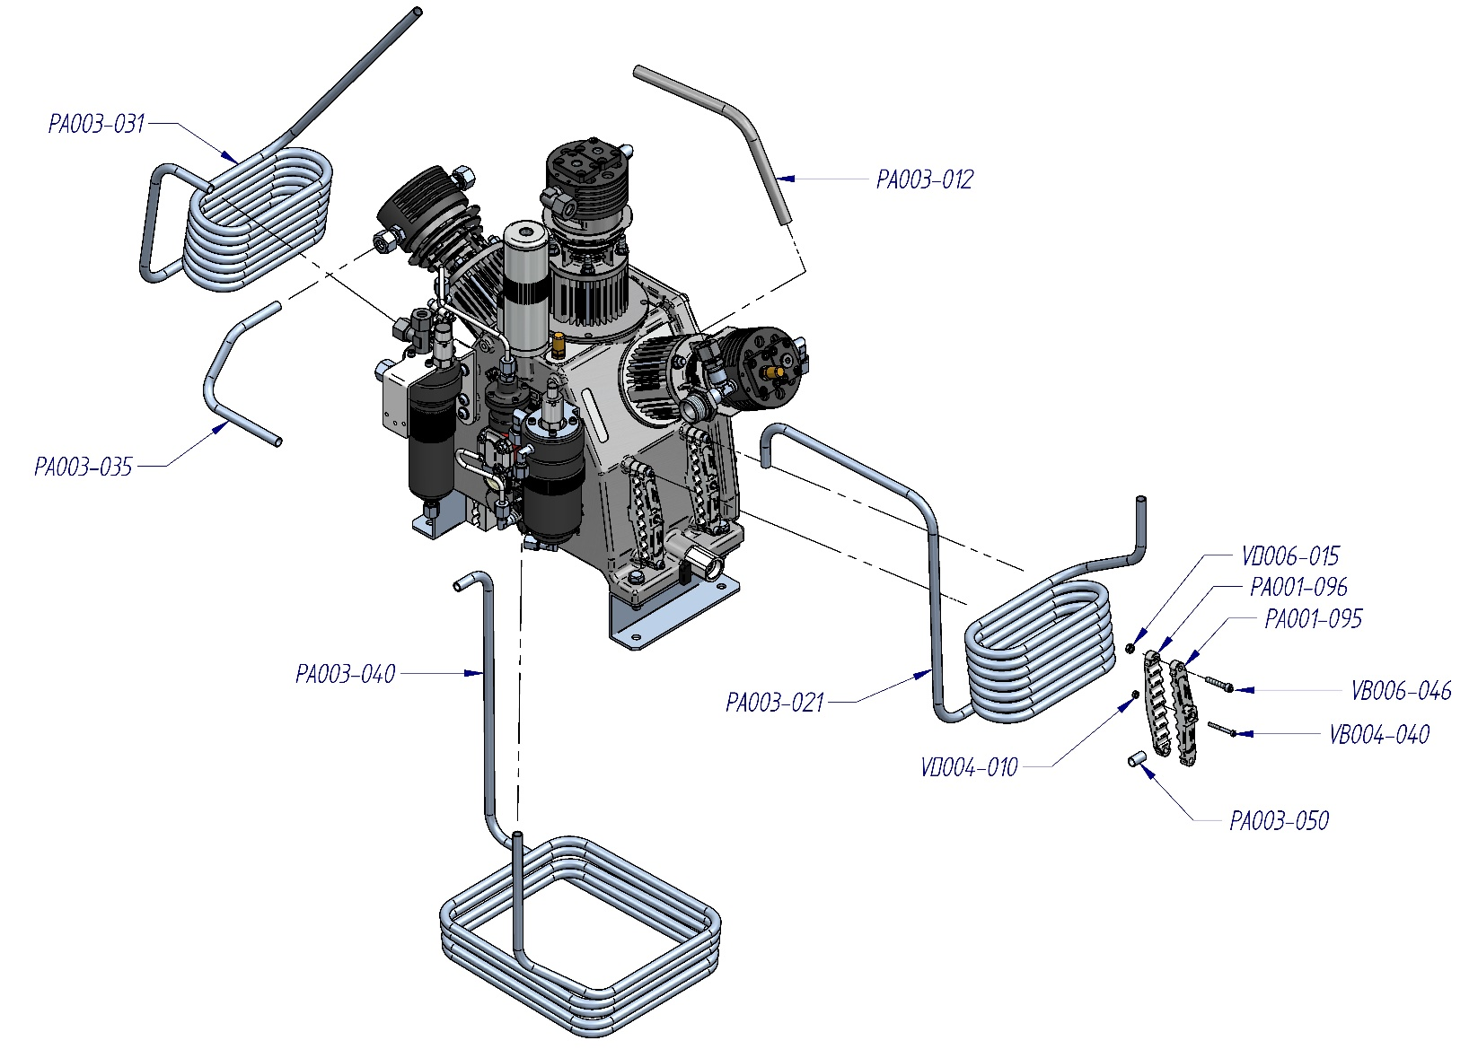

|  |  |  |  |  |  |  |  |  |
| --- | --- | --- | --- | --- | --- | --- | --- | --- |
| ***CODE*** | ***DESCRIPTION*** |  | ***CODE*** | ***DESCRIPTION*** |  | ***CODE*** | ***DESCRIPTION*** |  |
| **PA001-095** | *Fixing for cooler* |  | **PA003-035** | *Connecting tube* |  | **VD004-010** | *Nut* |  |
| **PA001-096** | *Fixing for cooler* |  | **PA003-040** | *Inter cooler* |  | **VD006-015** | *Nut* |  |
| **PA003-012** | *Connecting tube* |  | **PA003-050** | *Tube* |  |  |  |  |
| **PA003-021** | *Inter cooler* |  | **VB004-040** | *Screw* |  |  |  |  |
| **PA003-031** | *Inter cooler* |  | **VB006-046** | *Screw* |  |  |  |  |

|  |  |  |
| --- | --- | --- |
| NARDI LOGO SESAMO | **SPARE PARTS**  **BOOSTER 55 - 350**  ***Aspiration control*** | BOO005-014 Rev.01  Date 03/07/2015 |

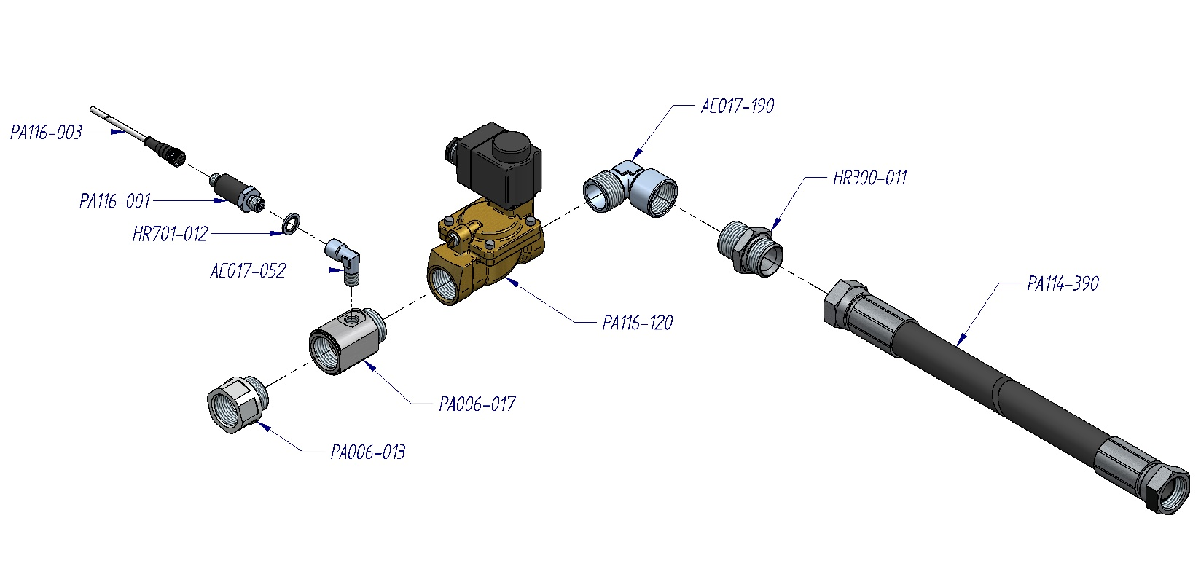

|  |  |  |  |  |  |  |  |  |
| --- | --- | --- | --- | --- | --- | --- | --- | --- |
| ***CODE*** | ***DESCRIPTION*** |  | ***CODE*** | ***DESCRIPTION*** |  | ***CODE*** | ***DESCRIPTION*** |  |
| **AC017-052** | *Pipe fitting “L”* |  | **PA006-013** | *Connection* |  | **PA116-003** | *Connector* |  |
| **AC017-190** | *Pipe fitting “L”* |  | **PA006-017** | *Connector* |  | **PA116-120** | *Solenoid valve* |  |
| **HR300-011** | *Connection* |  | **PA114-390** | *Tube* |  |  |  |  |
| **HR701-012** | *Washer* |  | **PA116-001** | *Transductor* |  |  |  |  |

|  |  |  |
| --- | --- | --- |
| NARDI LOGO SESAMO | **SPARE PARTS**  **BOOSTER 55 - 350**  ***Electric motor and belt*** | BOO005-016 Rev.01  Date 03/07/2015 |

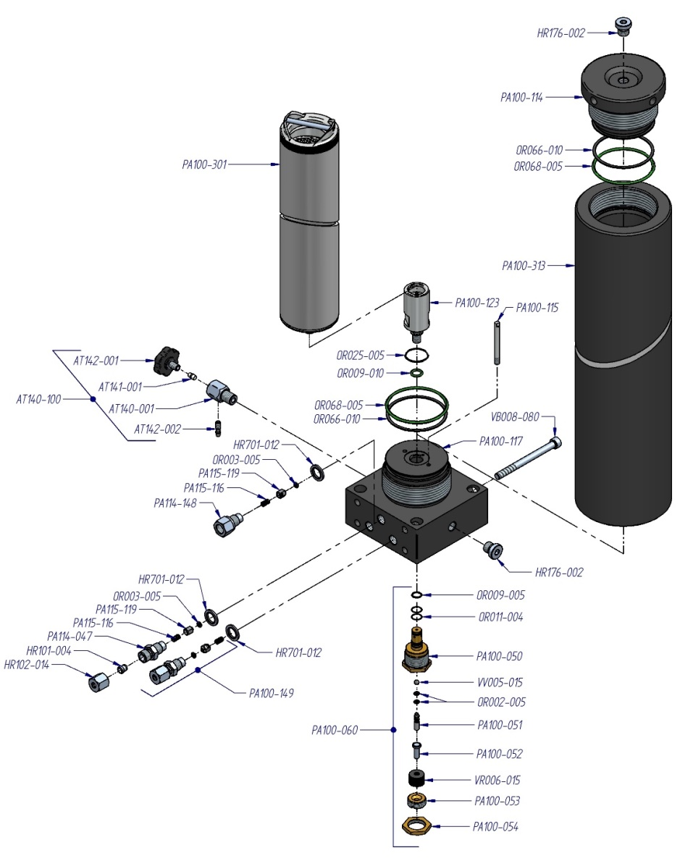

|  |  |  |  |  |  |  |  |  |
| --- | --- | --- | --- | --- | --- | --- | --- | --- |
| ***CODE*** | ***DESCRIPTION*** |  | ***CODE*** | ***DESCRIPTION*** |  | ***CODE*** | ***DESCRIPTION*** |  |
| **AT140-001** | *Drain valve housing* |  | **OR011-004** | *O-ring* |  | **PA100-115** | *Nozzle* |  |
| **AT140-100** | *Condensate drain valve complete* |  | **OR025-005** | *O-ring* |  | **PA100-117** | *Base filter* |  |
| **AT141-001** | *Rilsan nut* |  | **OR066-010** | *O-ring* |  | **PA100-123** | *Extension filter* |  |
| **AT142-001** | *Black screw of discharge* |  | **OR068-005** | *O-ring* |  | **PA100-149** | *Pipe fitting whit not return valve* |  |
| **AT142-002** | *Drain out* |  | **PA100-050** | *Maintaining valve insert* |  | **PA114-047** | *Connection* |  |
| **HR101-004** | *Ogive* |  | **PA100-051** | *Piston maintaining valve* |  | **PA114-148** | *Connection* |  |
| **HR102-014** | *Nut fitting pipe* |  | **PA100-052** | *Spring guide* |  | **PA115-116** | *Spring no return valve* |  |
| **HR176-002** | *Closure plug 1/4’’* |  | **PA100-053** | *Closure plug* |  | **PA115-119** | *Piston no return valve* |  |
| **HR701-012** | *Washer* |  | **PA100-054** | *Nut* |  | **VB008-080** | *Screw* |  |
| **OR002-005** | *O-ring* |  | **PA100-060** | *Maintaining valve complete* |  | **VR006-015** | *Washer spring* |  |
| **OR003-005** | *O-ring* |  | **PA100-301** | *Filter cartridge* |  | **VV005-015** | *Sphere* |  |
| **OR009-005** | *O-ring* |  | **PA100-313** | *Filter housing* |  |  |  |  |
| **OR009-010** | *O-ring* |  | **PA100-114** | *Head filter housing* |  |  |  |  |

|  |  |  |
| --- | --- | --- |
| NARDI LOGO SESAMO | **SPARE PARTS**  **BOOSTER 55 - 350**  ***Electric motor and belt*** | BOO005-012 Rev.01  Date 03/07/2015 |

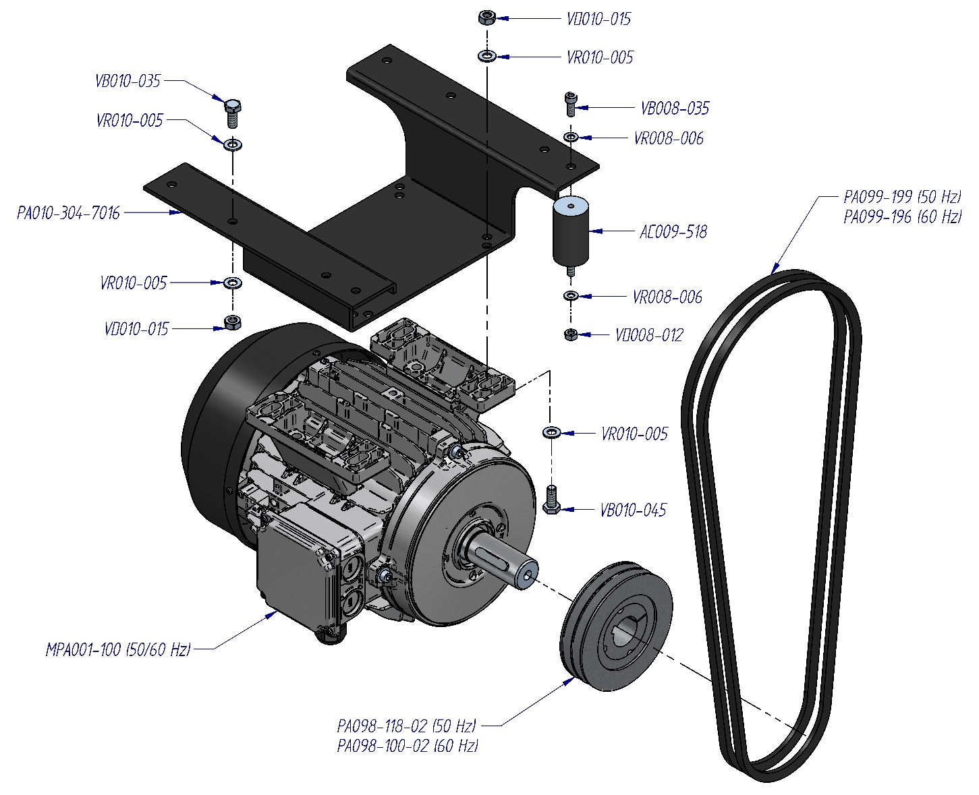

|  |  |  |  |  |  |  |  |  |
| --- | --- | --- | --- | --- | --- | --- | --- | --- |
| ***CODE*** | ***DESCRIPTION*** |  | ***CODE*** | ***DESCRIPTION*** |  | ***CODE*** | ***DESCRIPTION*** |  |
| **AC009-518** | *Antivibration* |  | **PA099-199** | *Belt* |  | **VD008-012** | *Nut* |  |
| **PA010-304-7016** | *Support* |  | **MPA001-100** | *Electric motor IE3* |  | **VD010-015** | *Nut* |  |
| **PA098-100-02** | *Pulley* |  | **VB008-035** | *Screw* |  | **VR008-006** | *Washer* |  |
| **PA098-118-02** | *Pulley* |  | **VB010-035** | *Screw* |  | **VR010-005** | *Washer* |  |
| **PA099-196** | *Belt* |  | **VB010-045** | *Screw* |  |  |  |  |

|  |  |  |
| --- | --- | --- |
| NARDI LOGO SESAMO | **SPARE PARTS**  **BOOSTER 55 - 350**  ***Internal frame*** | BOO005-013-A Rev.01  Date 01/07/2015 |

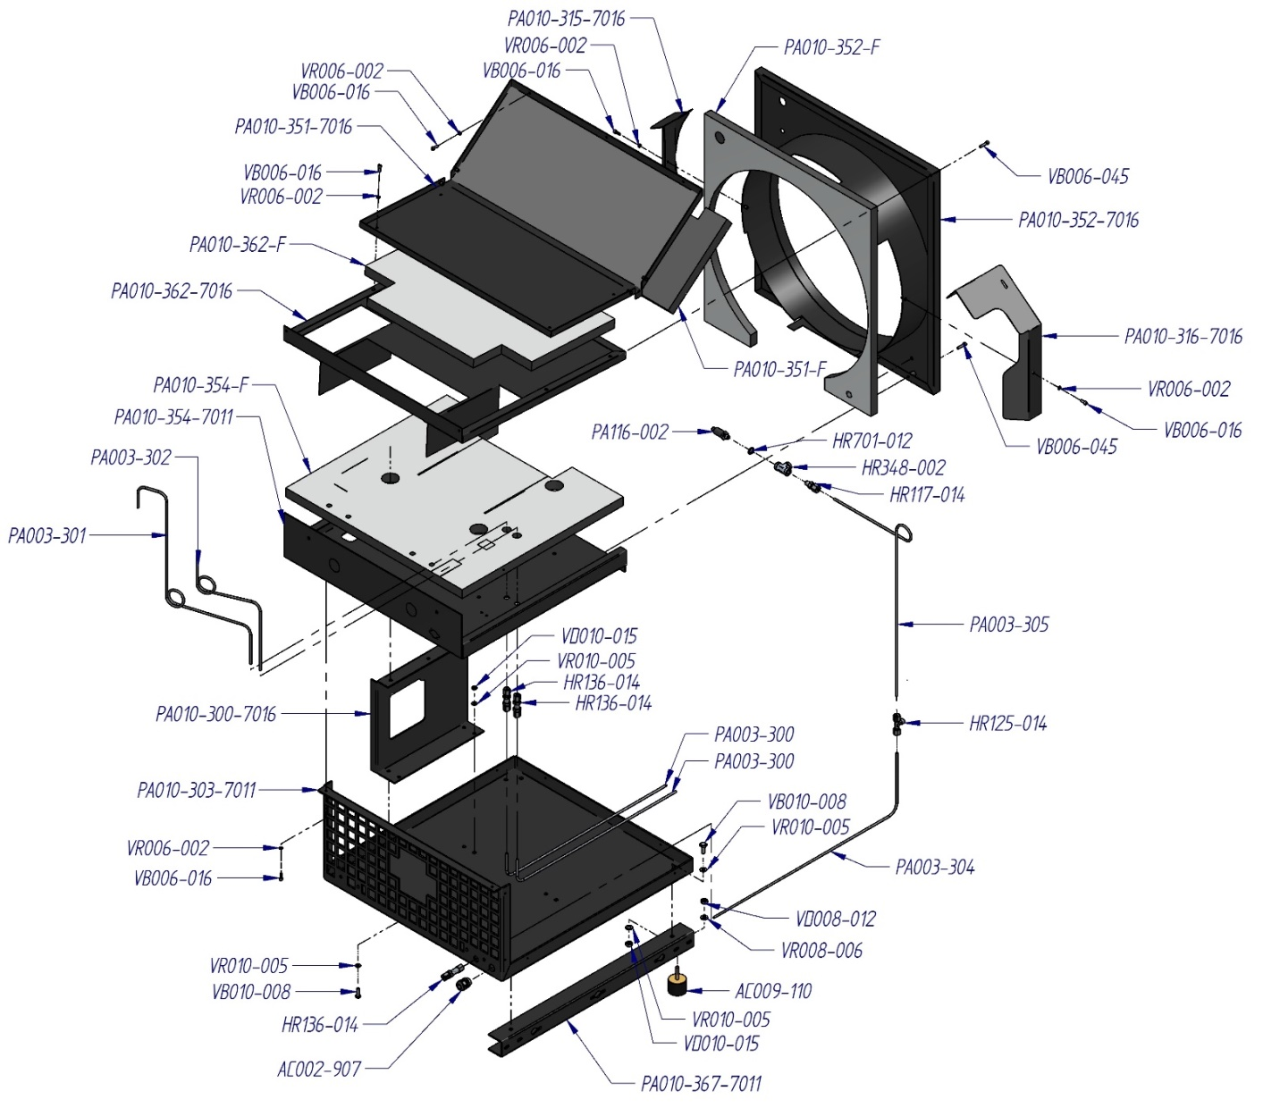

|  |  |  |  |  |  |  |  |  |
| --- | --- | --- | --- | --- | --- | --- | --- | --- |
| ***CODE*** | ***DESCRIPTION*** |  | ***CODE*** | ***DESCRIPTION*** |  | ***CODE*** | ***DESCRIPTION*** |  |
| **AC002-907** | *Cable gland* |  | **PA010-303-7016** | *Panel* |  | **VB006-016** | *Screw* |  |
| **AC009-110** | *Antivibration* |  | **PA010-315-7016** | *Conveyor* |  | **VB006-045** | *Screw* |  |
| **HR117-014** | *Pipe fitting* |  | **PA010-316-7016** | *Conveyor* |  | **VB010-008** | *Screw* |  |
| **HR125-014** | *Pipe fitting “T”* |  | **PA010-351-7016** | *Panel* |  | **VD008-012** | *Nut* |  |
| **HR136-014** | *Pipe fitting* |  | **PA010-351-F** | *Sound-absorbing* |  | **VD010-015** | *Nut* |  |
| **HR348-002** | *Pipe fitting “T”* |  | **PA010-352-7016** | *Panel* |  | **VR006-002** | *Washer* |  |
| **HR701-012** | *Whaser* |  | **PA010-352-F** | *Sound-absorbing* |  | **VR008-006** | *Washer* |  |
| **PA003-300** | *Tube* |  | **PA010-354-7016** | *Panel* |  | **VR010-005** | *Washer* |  |
| **PA003-301** | *Tube* |  | **PA010-354-F** | *Sound-absorbing* |  |  |  |  |
| **PA003-302** | *Tube* |  | **PA010-362-7016** | *Panel* |  |  |  |  |
| **PA003-304** | *Tube* |  | **PA010-362-F** | *Sound-absorbing* |  |  |  |  |
| **PA003-305** | *Tube* |  | **PA010-367-7016** | *Support* |  |  |  |  |
| **PA010-300-7016** | *Support* |  | **PA116-002** | *Tranductor* |  |  |  |  |

|  |  |  |
| --- | --- | --- |
| NARDI LOGO SESAMO | **SPARE PARTS**  **BOOSTER 55 - 350**  ***Esternal frame*** | BOO005-017-A Rev.00  Date 01/07/2015 |

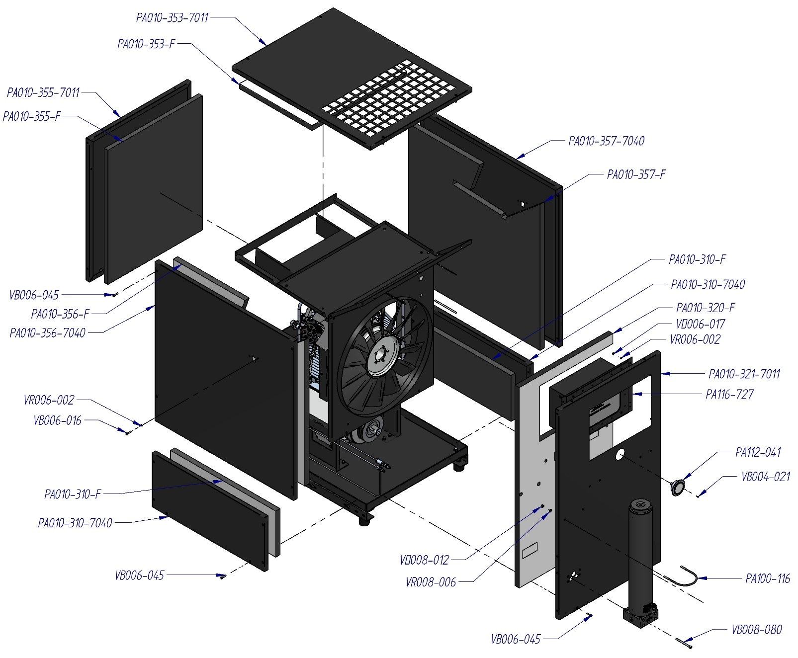

|  |  |  |  |  |  |  |  |  |
| --- | --- | --- | --- | --- | --- | --- | --- | --- |
| ***CODE*** | ***DESCRIPTION*** |  | ***CODE*** | ***DESCRIPTION*** |  | ***CODE*** | ***DESCRIPTION*** |  |
| **PA010-310-7016** | *Panel* |  | **PA010-356-F** | *Sound-absorbing* |  | **VB008-080** | *Screw* |  |
| **PA010-310-F** | *Sound-absorbing* |  | **PA010-357-7016** | *Panel* |  | **VD006-017** | *Nut* |  |
| **PA010-321-7016** | *Panel* |  | **PA010-357-F** | *Sound-absorbing* |  | **VD008-012** | *Nut* |  |
| **PA010-320-F** | *Sound-absorbing* |  | **PA100-116** | *Mounting bracket* |  | **VR006-002** | *Washer* |  |
| **PA010-353-7016** | *Panel* |  | **PA112-041** | *Manometer* |  | **VR008-006** | *Washer* |  |
| **PA010-353-F** | *Sound-absorbing* |  | **PA116-727** | *Switchboard* |  |  |  |  |
| **PA010-355-7016** | *Panel* |  | **VB004-021** | *Screw* |  |  |  |  |
| **PA010-355-F** | *Sound-absorbing* |  | **VB006-016** | *Screw* |  |  |  |  |
| **PA010-356-7016** | *Panel* |  | **VB006-045** | *Screw* |  |  |  |  |

|  |  |  |
| --- | --- | --- |
| NARDI LOGO SESAMO | **SPARE PARTS**  **BOOSTER 55 - 350**  ***Storage*** | BOO005-015-A Rev.00  Date 01/07/2015 |

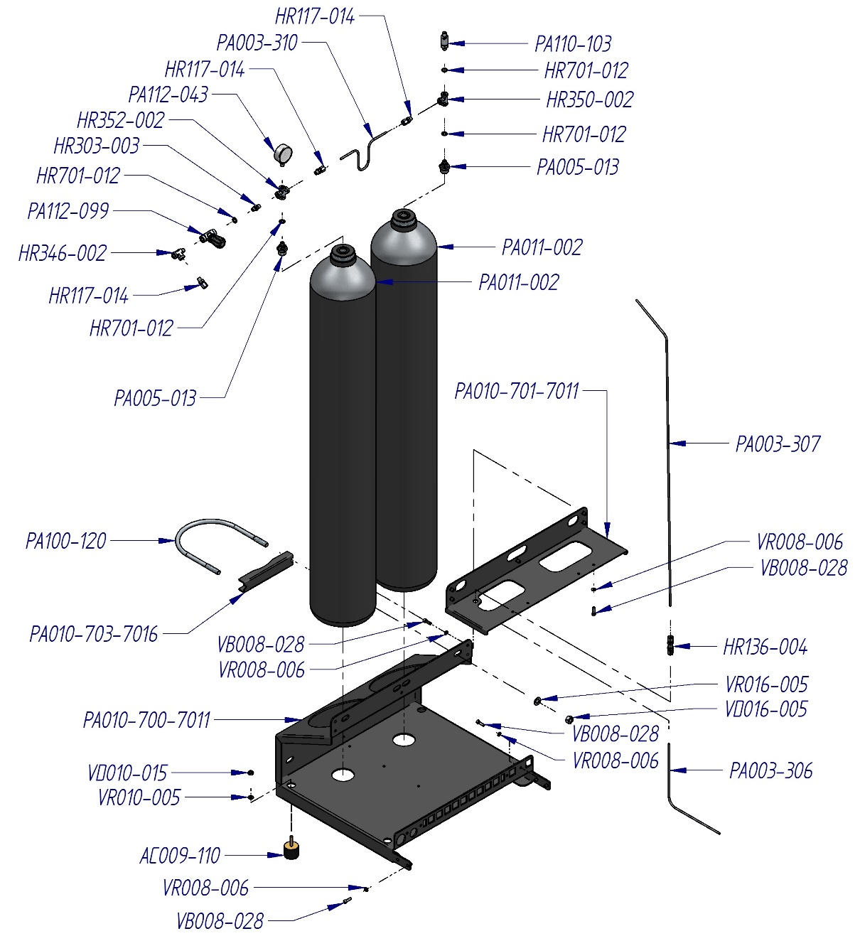

|  |  |  |  |  |  |  |  |  |
| --- | --- | --- | --- | --- | --- | --- | --- | --- |
| ***CODE*** | ***DESCRIPTION*** |  | ***CODE*** | ***DESCRIPTION*** |  | ***CODE*** | ***DESCRIPTION*** |  |
| **AC009-110** | *Antivibration* |  | **PA003-310** | *Tube* |  | **VB008-028** | *Screw* |  |
| **HR117-014** | *Pipe fitting* |  | **PA005-013** | *Reduction* |  | **VD010-015** | *Nut* |  |
| **HR136-004** | *Pipe fitting* |  | **PA010-700-7016** | *Support* |  | **VD016-005** | *Nut* |  |
| **HR303-003** | *Pipe fitting* |  | **PA010-701-7016** | *Support* |  | **VR008-006** | *Washer* |  |
| **HR346-002** | *Pipe fitting “T”* |  | **PA010-703-7016** | *Support* |  | **VR010-005** | *Washer* |  |
| **HR350-002** | *Pipe fitting “T”* |  | **PA011-002** | *Tank 350 bar* |  | **VR016-005** | *Washer* |  |
| **HR352-002** | *Pipe fitting “+”* |  | **PA100-120** | *Mounting bracket* |  |  |  |  |
| **HR701-012** | *Washer* |  | **PA110-103** | *Safety valve PN 300 bar* |  |  |  |  |
| **PA003-306** | *Tube* |  | **PA112-043** | *Manometer* |  |  |  |  |
| **PA003-307** | *Tube* |  | **PA112-099** | *Valve* |  |  |  |  |

|  |  |  |
| --- | --- | --- |
| NARDI LOGO SESAMO | **SPARE PARTS**  **BOOSTER 55 - 350**  ***Electrical box*** | BOO116-730-A Rev.00  Date 31/08/2015 |

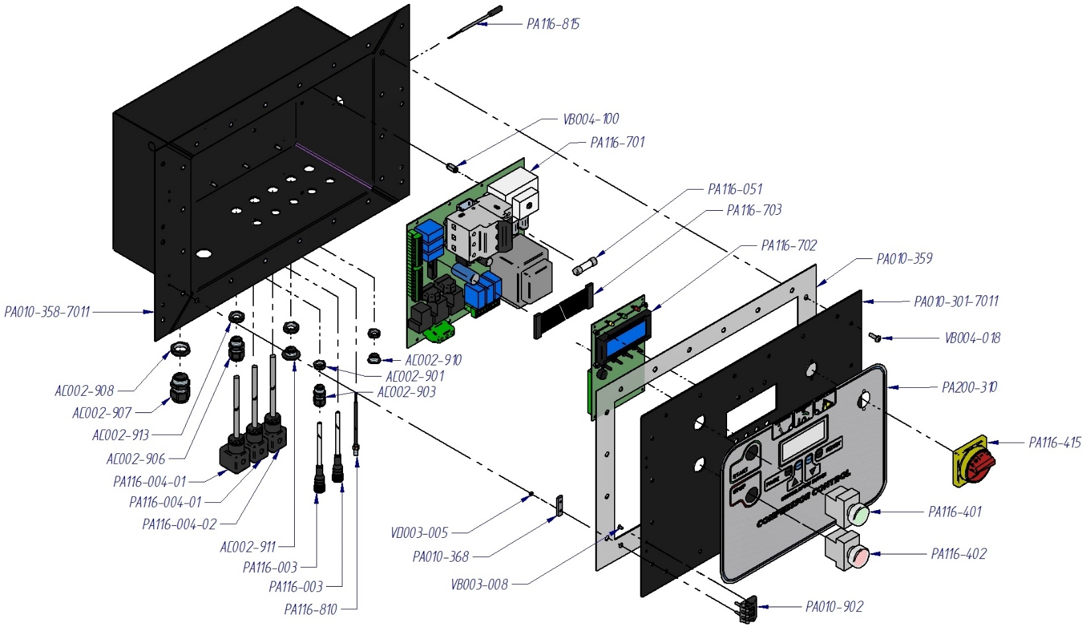

|  |  |  |  |  |  |  |  |  |
| --- | --- | --- | --- | --- | --- | --- | --- | --- |
| ***CODE*** | ***DESCRIPTION*** |  | ***CODE*** | ***DESCRIPTION*** |  | ***CODE*** | ***DESCRIPTION*** |  |
| **AC002-901** | *Nut PG7* |  | **PA010-368** | *Flange* |  | **PA116-703** | *Cable* |  |
| **AC002-903** | *Cable gland PG7* |  | **PA010-902** | *Hinged* |  | **PA116-810** | *Thermal transducer* |  |
| **AC002-906** | *Cable gland PG9* |  | **PA116-003** | *Connector* |  | **PA116-815** | *Thermal transducer* |  |
| **AC002-907** | *Cable gland PG13,5* |  | **PA116-004-01** | *Connector* |  | **PA200-3--** | *Sticker Nardi Industry* |  |
| **AC002-908** | *Nut PG13,5* |  | **PA116-004-02** | *Connector* |  | **VB003-008** | *Screw* |  |
| **AC002-910** | *Closure plug PG7* |  | **PA116-051** | *Fuse 20 A* |  | **VB004-018** | *Screw* |  |
| **AC002-911** | *Closure plug PG9* |  | **PA116-401** | *Button* |  | **VB004-100** | *Screw* |  |
| **AC002-913** | *Nut PG9* |  | **PA116-402** | *Button* |  | **VD003-005** | *Nut* |  |
| **PA010-301-7016** | *Electric box panel* |  | **PA116-415** | *General* |  |  |  |  |
| **PA010-358-7016** | *Electric box* |  | **PA116-701** | *Board electric power* |  |  |  |  |
| **PA010-359** | *Gasket* |  | **PA116-702** | *Board electronic control* |  |  |  |  |

**9 *TABELLA CONTROLLI PERIODICI***

|  |  |  |
| --- | --- | --- |
| EVER 1000 HRS | DATE | OPERATOR |
| CHANGE THE CARTRIDGE FILTER |  |  |
| SERVICE KIT 2000, 6000, 10000HRS | DATE | OPERATOR |
| SERVICE KIT 4000, 8000, 12000 HRS | DATE | OPERATOR |